Revision Unit 8

1- He has been studying Biology ( Since – for ) three years.
2-She has been a nurse (since – for ) 1980 .
3- I have been working here (since – for ) five months.
4- They have been touring Egypt (since – for ) two weeks .
5- We’ve been ( travelling – travel – travelled ) for ten days.
6- Tariq ( have – is – has ) been driving a car since last summer.
7- Cheques ( was – were – is ) used by Arabs in China in the 9th century.
8- Algebra was ( taken - took - taking ) from Arabic.

Do as shown between brackets :

1- I’ve been writing this e-mail for 10 minutes. ( Ask a question )

2- " Don’t waste your time " (Report the instruction)

3- "pray on time " our father / us ( Report the request)
___________________________________________________________
4- " Please do not make a lot of noise" Mum /my brother( Report the request)

5- "study hard for the exam" Our teacher / us( Report the instruction )
___________________________________________________________

6- Ibn Al-HaythamestablishedThe science of optics.(change into passive )

Fill in the missing words :

Vaccination - Biology-progress - Cheques-soap - zoom-

1-I don't use credit cards to pay money. I use ____________________
2-We use ____________________for washing our faces and bodies.
3-____________________ protects our children from dangerous diseases.
4-Technology helps in the ____________________ of our country.
5-The ____________________of the camera helps to make photos bigger and clearer.
6-____________________ is the science which studies bodies of people, animals and plants.
Write the correct words under each picture:
Laboratory - Zoom - soil – irrigate - degree

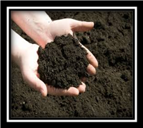
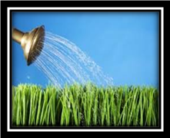
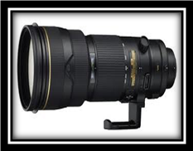


_________ __________ ____________ ________ __________

رؤيتنا: الريادة في التربية والتعليم لإعداد جيل مبدع في ضوء الجودة التعليمية والمشاركة المجتمعية .

