

Distribution of the Syllabus - the 6th Elementary Stage ( We Can 6 ) the 2nd Term 1438 – 1439 H

6th week | 5th week |  | 4th week | 3rd week | 2nd week | 1st week
9 / 6 – 13 / 6 | 2 / 6 – 6 / 6 |  | 25/ 5 – 29 / 5 | 18 / 5 – 22 / 5 | 11 / 5 – 15 / 5 | 4 / 5 – 8 / 5
Unit 3  My School is Cool  - Finding out time  - Grammar in action | - Phonics  ( Phonic Practice page 52 – 53 ) |  | Test  -Rhythms & Reading | Unit 2  Life's Ups and Downs  - Finding out time  - Grammar in action | - Rhythms & Reading  - Phonics  ( Phonic Practice page 50 – 51 ) | Unit 1  Fun on the Weekend  - Finding out time  - Grammar in action
12th week | 11th week |  | 10th week | 9th week | 8th week | 7th week
22 / 7 – 26 / 7 | 15 / 7 – 19 / 7 |  | 8 / 7 – 12 / 7 | 1 / 7 – 5 / 7 | 23 / 6 – 27 / 6 | 16 / 6 – 20 / 6
Test | - Rhythms & Reading  - Phonics  ( Phonic Practice page 58 – 59 ) |  | Unit 5  Hanging Out in Town  - Finding out time  - Grammar in action | - Rhythms & Reading  - Phonics  ( Phonic Practice page 56 – 57 ) | Unit 4  A Healthy Life  - Finding out time  - Grammar in action | - Rhythms & Reading  - Phonics  ( Phonic Practice page 54 – 55 )
17th week |  | 16th week |  | 15th week | 14th week | 13th week
27 / 8 – 2 / 9 |  | 20 / 8 – 24 / 8 |  | 13 / 8 – 17 / 8 | 6 / 8 – 10 / 8 | 29 / 7 – 3 / 8
Evaluations  FINAL  EXAMS |  |  |  | Revision  Phonics practice | - Rhythms & Reading  - Phonics  ( Phonic Practice page 60 – 61 ) | Unit 6  My Dream Vacation  - Finding out time  - Grammar in action

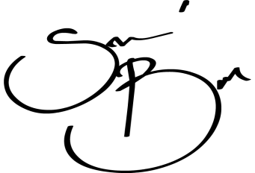
Teacher : Badr Sayid Al-Shehri Principal : Ahmad Ali Al-Shehri
Signature : Signature : ……………………

