General Revision 3rd Sec . Mega Goal 1436
Gramm . A/ Choose the correct words :
- I need two ( others - other - another ) pens.
- The carpenter fixed ( others - another - other ) chair yesterday.
- If you help people, ( other - others - another ) will help you.
- I ( do - does - done ) delay my party.
- He ( do - does - did ) break the sound barrier last year.
- She ( do - does - done ) marry her cousin.
- I ( used to - am used to - use to ) sleeping late.
- My grandfather ( used to – is used to - using ) get water from wells.
- We didn’t ( use to – used to –are used to ) care about football.
- By next month we ( will have finished – will have been finishing – finish) Eng.
- Rasha ( will have studied – will have been studying- study) for 3 years.
- After she (graduated – graduates – graduating) , she will get a job.
- When you ( drive – drove –drives ) fast, the police will stop you.
- Neither my mother nor my aunts ( comes – come – coming )to the party.
- neither my aunts no my mother ( comes - come - coming ) to the party.
- Both me ( but – and – so ) my sister were absent yesterday.
- Badr studies hard ( only if – unless – so that ) he can join university.
- People eat ( because – in order to – unless ) to live.
- Someone follows him ( only if – wherever – if ) he goes.
- Don’t forget ( switch – to switch – switching ) off the lights when you leave.
- I remember ( riding – to ride –rode ) bicycles when we were young.
- Fadwa understands the lesson , but Hana ( isn’t – wasn’t - doesn’t )
- The launch was rescheduled ( so – but – and ) the mission took place later.
- I don’t like shrimp and neither ( does – do - did ) she.
B/ Add emphatic (do):
- She feels proud of her father. ………………………………………..
- Doctors attempted to use different medicines. …………………………………..
- I pass the test . ………………………………………………………
C/ Correct the error :
- Neither Nada nor her friends shares in the competition. ---------------
- Neither her friends nor Nada share in the competition. ---------------
- Both my father and my uncle is present in the meeting. ---------------
- She will sleep until the sun shine. -----------------------------
- By the summer, we ( graduate ) ------------------------------
- Because she blows money she was broke. ---------------------------
7. They didn’t used to have computers. ----------------------------
D/ Make the sentence negative :Unit : 2
1. Hatim used to feed his guests. ----------------------------------------
E. Change into passive :Unit :6
1. Patients like someone caring about them .
…………………………………………………………………………
2. The baby wants his mother to feed him.
…………………………………………………………………………
F/ Combine the 2 sentences using paired conjunctions :Unit :4
- Nora will cook dinner. Sara will cook dinner.
……………………………………………………………………………………………………………
- Prophet Mohammad was honest . He was truthful.
…………………………………………………………………………………………………………….
- The soup wasn’t hot. The soup wasn’t spicy.
…………………………………………………………………………………………………………….

Vocabulary : A/Match expressions to their meanings :
- on the same wavelength = thinking the same thing
- not my cup of tea = a polite way to say you don’t like something.
- drive someone crazy = greatly annoy or irritate.
- get cold feet = decide not to do something because you are scared.
- lugging = carrying
- go with the flow = accept things
- a dime a dozen = not having much value .
- broke = out of money.
- blow = waste money.
- know like the back of my hand= know very well.
B/Match words to their opposites : ( synonyms # antonyms )
Unit : 1 unified # separate
Grieve # be happy / relieve
Reject # accept / agree

Unit : 2 prominent # ordinary
Impoverished # rich/ wealthy
Dismantle # assemble

Unit : 3 condensed # long
Obsolete # new / modern
Lucrative # unprofitable
Rigorous # careless/ easy

Unit : 4 Ally # enemy
Evil # good
Epic # short story

Unit :5 artificial # natural /real
Dull # interesting
Exclusive # unlimited / shared
Outlandish # common / normal
Sophisticated # unsophisticated

Unit : 6 feminine # masculine
Significant # insignificant
Restless # calm / quiet Literal # false
C / Fill in the blanks with the correct word :
Companions - exiled – chuckle – charity – dispute – hurdles – philanthropist – resign – optimize – condensed – rigorous – gaze – sanitation – ally – villain - delusion – abrupt – exotic – enduring – crucial – brand – consumer – implement – covet – admire – exclusive- outlandish –obsolete –sophisticated –gender –feminine – masculine –tedious–literal –witness.
- Khadeeja was the best ……………………………… of prophet Mohammad.
- Syrians were ……………………………. From their native country.
- I heard the …………………………….. at the joke.
- Poor people need …………………………..
- The ………………………….. between the two neighbors was about car parking.
- Many………………………… prevent him from marriage.
- The ……………………………………. donated millions to shelter orphans.
- His health compelled him to ……………………… from his job.
- We manage our time so we ………………………………our productivity.
- The article was ………………………………….. into a few lines.
- The government promised ……………………………….. regulations.
- The restaurant improved …………………………………. To keep customers.
- Russia was an ……………………. for England in the Second world War.
- The hero killed the …………………………… .
- ……………………………. Can be a symptom of mental instability.
- The ………………………… stop of the car was terrible.
- This …………………………. fruit is delicious.
- The …………………………… happiness is in Paradize.
- All vitamins are ……………………………….. to health.
- I always buy Mac ……………………….. for make up.
- Humans are the top ……………………………….. in the world.
- The plan was not ……………………………….ed correctly. Guns are the ………………………. for death.
- It is bad to ………………………….. what others have.
- The person I …………………………….most is Prophet Mohammad.
- The reporter got an ……………………………….. interview.
- Clothes shouldn’t be ……………………….. yet they should be stylish.
- The dictionary of 2001 is ………………………………
- New York is a ………………………………………… city.
- Islam doesn’t care bout ……………………………. But about deeds.
- …………………………………… and ……………………………………. Are different genders.
- The book is ……………………….. to read.
- It doesn’t mean the ……………………………….. description of the situation.
- There was no ………………………………….to their conversation.

D/ Write the word under the suitable picture :
Pictures : [ vehicle - space craft – surgeon – predators – magnifying glass – ostrich- sneakers- anemones – ratel- beehive – claw – poultry – crib – hides – detergent –
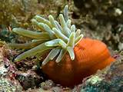
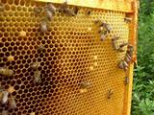
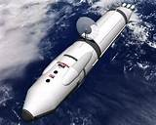
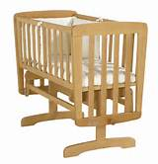
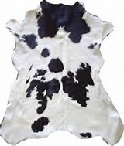

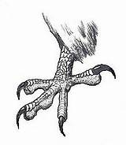
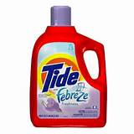
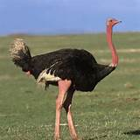
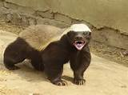
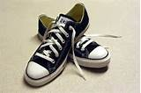
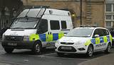
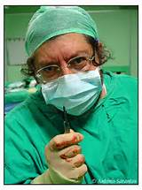
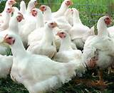

Best wishes . Teacher / Nawal

