Answer the flowing question:
A: Hi .
B: …………
A: What day is it ?
B: ………………….
A: What color is the egg ?
B: ………………….
A: What shape is this ?
B: ………………….
A: Where are you ?
B: ………………….
A: Thank you.
B: …………………..

A: Good morning.
B: …………………..
A: What is your name?
B: …………………..
A: How are you?
B: ………………….
A: How old are you?
B: ………………….
A: What are you ?
B: ………………….
A: Goodbye.
B : ………………….

8-Where is Ali?
……………………………………

9-Where is Hind ?
……………………………………
[ page : 15 ]

10- What color is the egg ?
……………………………………

11- What color is the apple?
……………………………………

12- What color is the banana ?
……………………………………

13- What color is the pen ?
……………………………………

14- What color is the board ?
……………………………………

[ page : 18 ]

1- What is your name?
……………………………………

2- How are you?
……………………………………

3- How old are you?
……………………………………

[ page : 5 ]

4- What is this?
……………………………………

5- What is that?
……………………………………

6- What are these?
……………………………………

7- What are those ?
……………………………………
[ page :7-13-14-17-21]

23- What day it is\\What is today?
……………………………………

……………………………………

[page : 24
______________________________________
Write the plural :
.a book 4………….s

.a potato 6………….es

.a city 2……………ies

[ Page :1214-19]

Choose:
1- ……… is Ali.
a- He . b-She . c- It d- You.

2- ……… is a board.
a- He . b-She . c- It d- They.

3- ………. are a school girl .
a- He . b-She . c- It d- You .

4-……… is Fatimah .
a- He . b-She . c- It d- You

5- ……… are family .
a- He . b-She . c- It d- They.

6- I ……. a nurse .
a- am. b- is. c- are.

7- He ……. an engineer.
a- am. b- is. c- are.

8- They ……. doctors.
a- am. b- is. c- are.

[page : 10 - 16 ]

15-Where are you from?
……………………………………

16- What city is this?
……………………………………

……………………………………

……………………………………

……………………………………
[page : 19 ]

17-Where is he?
……………………………………

18-Where is she?
……………………………………

19- Where are they ?
……………………………………
[page : 20 ]

20- What shape is it ?
……………………………………

……………………………………

……………………………………

……………………………………
[page :21 ]

21- What is he ?
……………………………………

……………………………………

……………………………………

……………………………………

……………………………………
22-What is she ?

……………………………………

……………………………………

[page : 23 ]

Put [ a ] or [ an ]:
1- This is …… egg . 2- That is …..book . 3- It is …. Circle .
4- These are …..cats . 5- Those are …. dogs. 6- I am ….schoolgirl.

Match:

-This a teacher.
- These potatoes.
-Those lemons.
- That a chair.
[page :12 - 16 - 17 ]
Answer these questions :

1- What is this ? 2- What is that ?
…………………… …………………...

3-What are these ? 4-What are those?
…………………….. …………………….

[page : 7 – 13 – 14 – 16 – 17 – 18 –19 – 20 -21 ]

is

are

VOC.: [page :1 ,2 ,3 ,4 ,6 ,7 ,14 ,15 ,19 ,20 ,21 ,22 ,23 ]

Match: A]1- Mother 2-nurse 3- bag 4- key 5- circle

Write the missing letter : kitch_n air_ort sis_er sha_es

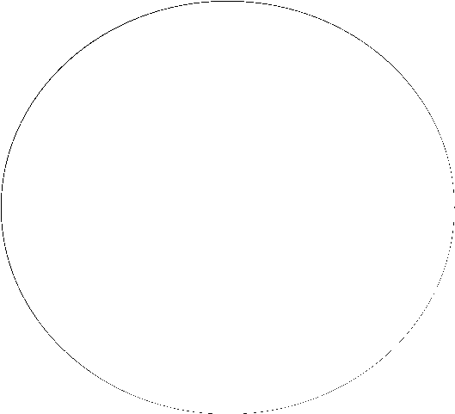

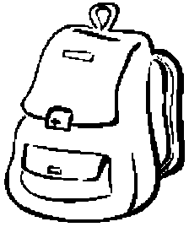

B] - tall

-triangle

-Apple

-zebra

-father

Rearrange :
A] S – j – h – n – y – f – t – c – w
…………………………………………..

B] 24 - 98 - 65 - 76 - 54 - 8 - 2 - 88
…………………………………………..

C] Sat.\ Tue.\ Sun.\ Fri.\ Mon.\ Thu.\ Wed.
..…….. ……….. ………… ……….
………. ………… …………

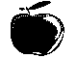
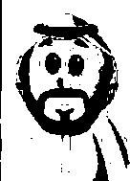

Write the opposite :
-hot # ..…… -tall #..…… -read #..……
–stand up # ..……. -big #..……
-open#..…… -stop#..…… -good#..……

Answer
What is it like ? it is……….
[page :6 - 22 -26 ]
Color the shapes :
-The big balloon is red
-The small balloon is green

-The tall triangle is blue
-The short triangle is black

