

The Final Exam for 3rd Grade
Second Term
1435- 1436 AH
Time: Two Hours

المملكة العربية السعودية
وزارة التربية والتعليم
الإدارة العامة للتربية والتعليم الطائف
مجمع عتاب بن اسيد
الصف الثالث متوسط

 |  | Corrected by
30 | Thirty marks | Total marks

الاسم /Name: …………………………………………………………………………………………………….........…………………….

Q.1 –
Read the passage and answer the questions below:
The Last Prophet Mohammad (PBUH) Prophet Mohammad (PBUH) was born in Makkah . His Father, died before he was born. His mother, died when he was a child of 6 years old. He lived with his grandfather Mohammad (PBUH) worked as a shepherd. He was always honest and people called him “AlSadiq AlAmeen “. He started spreading the message of Islam in Makkah. After fourteen years he move to Al Madinah. The people of Al Madinah supported him a lot . He died in the year 11 of AL Hijra in Al Madinah .
A- Choose the correct answer:
1- Prophet Muhammad (peace be upon him) was born in...............
a- Makkah c- Riyadh d- Madinah
2- A shepherd is a person .................
a- who teach a children b– who looks after a sheep c- who drive a cars
3- His mother, died when he was
a. 10 years old. b. 12 years old. c. 6 years old.

Q.2 –

A- Choose the correct vowel:

u | o
a | i
e | i
a | m

d__rty no___se mo___th na__e

C- Choose the correct words:
1- A……………………. MAKES NEW COLTHES .
Pliceman . potter. Tailor.
2-…………………….. save the goal .
Doctor teacher goalkeeper.
3- What …………. Your name ?
Am is are
4- In our book, there are…………………………
5 units 3 units 10 units

Continued behind Page.
تابع خلف الصفحة
Q.3-

A / Choose the correct answer :
- I ( has – have – am ) car .
- ( he – You – We ) has read the book .
3- I want to ( go – went – goes ) home.
4- he asked ( he –him –I) to talk about himself.
B-Complet
box |  | Boxer
 | Working | worker
 | Playing | player

Q.4-
A) Write the correct word under each picture :-

( camel - car - computer - goalkeeper - red card - bus )

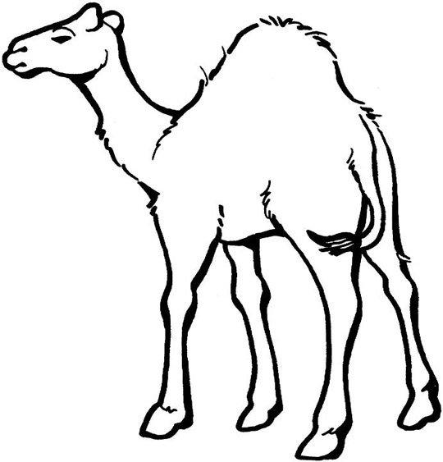
...............................................................................................................................



...............................................................................................................................

B- Copy the following sentence:

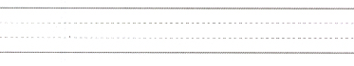
Everyone have to work hard to live a better life.

