Write the correct word under each picture :
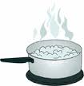
( sink /experiment/ boil/fresh/float / freeze / )
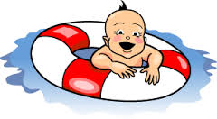
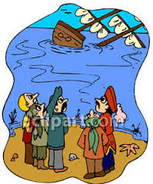
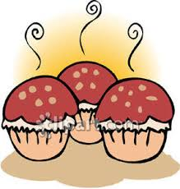
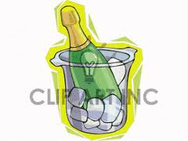
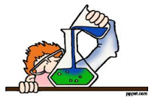

………………… …………………… …………………… …..………..…… …………………… …………..………

Match the opposite :
1-float # freeze .
2-fresh # dense .
# sink

Choose :
1- If you ( heat / heats / heating ) ice , it ( become / becomes / becoming ) water .
……………………………………………………………………………

Complete :
1- If you put pencils in water ,………………………………………..

E.T :Lamia Al-Fadil

