
المملكة العربية السعودية
وزارة التربية والتعليم الإدارة العامة للتربية والتعليم بالمنطقة الشرقية
الشؤون التعليمية-بنات / إدارة الإشراف التربوي
مكتب التربية والتعليم في راس تنورة المدرسة: الثانوية الاولى راس تنورة
المادة: اللغة الانجليزية
الصف الدراسي: ثاني ثانوي مقررات – المستوى الثاالث Traveller 3
العام الدراسي: 1434-1435هـ


Teacher: Naela Ali Alamer

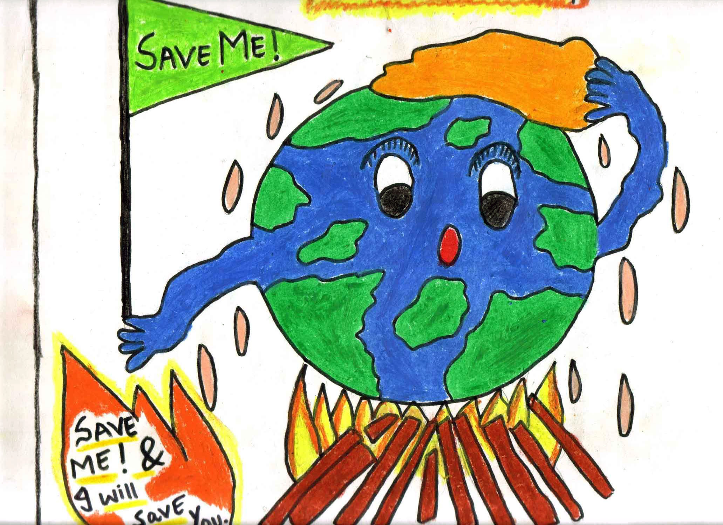

4a reading

Objectives:
- Recognize the importance of volunteering.
- Discuss ways of volunteering and providing good deeds to society
- Identify problems that endanger planet earth
- Read for gist and identify main ideas
- Identify meaning of new words form context
- Relate rephrased ideas with the original ones
- Give solutions and ways to protect the earth.

Materials:
PowerPoint show – worksheets – different strategies – a short video clip

Anticipatory set:
A - Gaining Attention:
5 min. activity
- Use the strategy of (who am I) to discover the key word of the lesson which is (Volunteering)
- Choose 2 girls to do the activity. The 1st girl will hold a paper on her back with the word (volunteer). The S. will go around the class to ask questions about the word starting with the guide word “help”
- Discover and define the word “volunteer”: person who does a job or some work without being paid or forced to do it

B – Revision:
- Use the strategy : (Give One, Get one)
- List all the topics covered in the previous module.
C – Set readiness.
- Show a short video clip about the problems of planet earth
- Use the strategy “open question”. On a PowerPoint show, I’ll present some pictures of the planet earth asking for help and other pictures showing the problems surrounding the earth.
- I’ll generate a discussion based upon Ss’ personal life and experiences.
- Ss. are expected to number some of the problems on earth like, pollution, poverty and natural disasters.
- I’ll end this discussion by this question “Have you ever thought of volunteering to help solving these problems? Why ? why not?
D- Objectives for students:
- Discuss environmental issues based on personal experiences.
- Identify the importance of volunteering to help saving the earth.
- Practice scanning reading to identify main ideas and key words
- Paraphrase ideas from the context
- Identify meaning of new words from context
New vocabulary
Words related to the environment
canyon - chain of islands - coast - coastal desert - ecosystem - environment - flood (n) - jungle - oasis - ocean - - paradise - plant (n) - polar – ice- cap - pond - rainforest – sandy - species - tropical - volunteer (v)

Other words
Affect - agency – amount- beauty - challenge (n) - community - cover (v) – create- description - destruction – development - eventually fit (v) generation- global – hardworking - harmful - housing - individual (n) - length - miss out - protection - reduce - stretch - train (v) – treasure- unique - youth

Instructional Input:
- I divide the class into groups. Each one is assigned with one paragraph.
- Use the strategy of “reading scanning”. Each group read the paragraph and underline the difficult words and identify the main idea of it which is the purpose of the organization.
- After scanning the material given, Ss. write the required facts in the table given for reading scanning.
- Ask each group to guess the meaning of the new words.
- Write them on the board. Have a quick repetition.
- Ask each group to choose a leader or speaker to explain the purpose or the main ideas discovered in their material and thus all the class cover all the texts and identify their ideas
- Ask some comprehension questions.
- Do you think that people nowadays volunteer to solve environments problems?
- Why are scientists worried about the Amazon basin?
- What does the charity warehouse want to help with?
- Do activity C. Match paraphrased sentences to the appropriate text.
- Do activity D. Match the words with their meanings
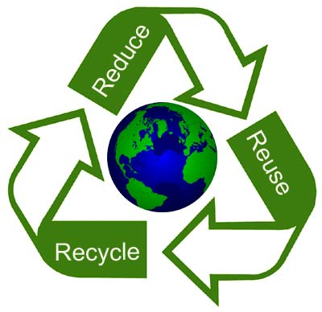
- Give the students the opportunity to talk about the most appealing volunteer work and explain the reasons.
Checking understanding:
Use the strategy “ Fan – N - Pick”
I design cards with the following questions.
- Which paragraph talks about….
- Preparing youth for the future. ( A )
- Help affected people by the flood ( D )
- Help scientists in their study of the destruction of the Amazon ( B )
- Help compare satellite images to on-the-ground information. ( C )
Guided Practice.
- Use the strategy of “People hunt”
- A student from each group has to search and find who can answer the questions below
- Fill in the spaces with correct words
- Jeddah faced a great flood that destroyed it.
- We have to stop cutting trees because logging will reduce the size of rainforests by 60%
- The world is experiencing a time of change
- Why not consider volunteering to save planet earth?
Independent practice.
Use the strategy of “ Card Out”
Choose 3 words, explain their meaning and give examples.
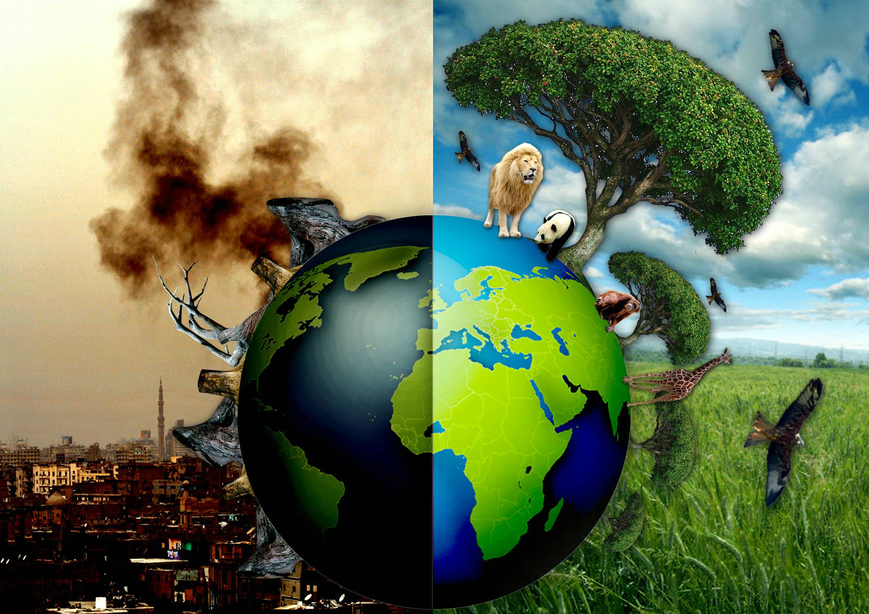
Closure.
Use the strategy of “Get One, Give One”
How can you save the planet?



