
بسم الله الرحمن الرحيم
9
Name: …………………………………

أتقن لم يتقن (Skills N.4)

1 Match :
2
1- Where are you from ? He is in the bedroom .
2- Where is Ahmad ? I am from Saudi Arabia .

أتقن لم يتقن (Skills N.17)

2 Form words from the following letters :
1
i - e - l - n = …………………………………………

e - l - b - u = …………………………………………

أتقن لم يتقن (Skills N.18)
2
3 Copy :

Ahmad is in the supermarket .

أتقن لم يتقن (Skills N.30)

7 Choose :
2
1- ( This - That ) is a pen .

3- ( These - Those ) are tomatoes .

5- It is ( a - an ) door .

6- It is ( a - an ) apple .

ANIMALS YOU CAN SEE AT THE ZOO
A story by Rolando Merino for his son Rolli
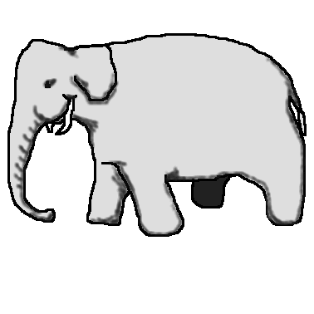
This is an elephant. They are very big animals and have a long memory,
and a very long nose called a trunk.
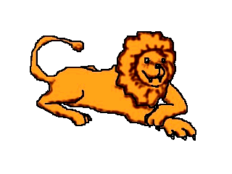
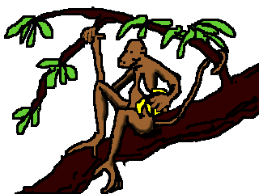
This is the lion. It is the king of the jungle .
This is a monkey. They spend a lot of time up in trees and like to eat fruits.
This one has a banana.

2
أتقن لم يتقن (Skills N.11)
أتقن لم يتقن (Skills N.8)
أتقن لم يتقن (Skills N.20)
أتقن لم يتقن (Skills N.30)


Good Luck

