
Name : …………………………… Class : ………………
How is your result ?
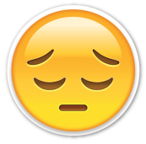  try harder |   well done
worksheet : ( )

Rewrite this paragraph :
At six o'clock , I get up and brush my teeth .
At one o'clock . I finish school and walk home .
At two o'clock , I eat my lunch . At Five o'clock ,
I play football with my friends . At ten o'clock I
Jump into bed and dream a lot .

