
Revision Unit ( 1 )
سبحان الله و بحمده سبحان الله العظيم
My Name …………………………………………………………………………………………………………………………………………..

Q 1: Write the correct word under each picture :


( Science - math - history - head teacher – art – sport - friends – assembly – P.E. – Technology – scared )
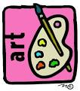
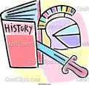
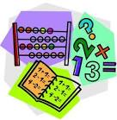


……….. ……… ………. ………. ………


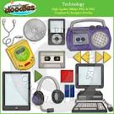
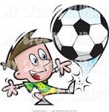

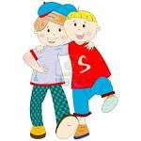

……… ….…… …..…… …….... …….. ……….
Q 2: Write the question :
1- How long / your break .
………………………………………………………………………………….
2- How long / fortnight .
……………………………………………………………………………….....

Q3: Give the abbreviation :
1- United State of America.
2- United Kingdom . ………………….

Q 2: Choose :
1- They ( are having – had ) an assembly yesterday .
2-We ( are having- had ) a lot of work tomorrow .
3- ( Tomorrow – Yesterday ) he is having a meeting .


Mrs: Lamia

