Quiz Unit 4 (life's a journey)
Name: Class:
- Form :
1-Who was the 1st man landing on the moon?
……………………………………………………………………………………………………………………….
2-Grammar: Do as required in brackets:
1-May /your email/ I /address/take? ( Rearrange)
……………………………………………………………………………………………………………………………..
2-It’s a good thing Reem didn’t hear what you said.She (could –would-should ) have been nervous (Choose)
3-We went to Rome in winter. It was v. cold. ( Write the sentence with a correct modal)
…………………………………………………………………………………………………………………………….
4-Look ,there's Sara's book.She …………………………….(forget) (complete with appropriate modal)
3-Vocab: Write the correct word for each picture:
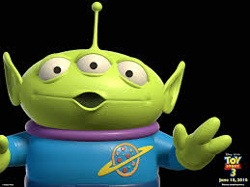

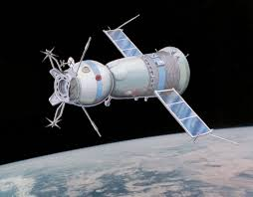
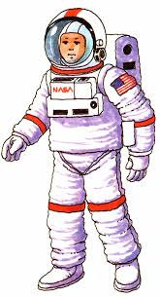

1………………………………. 2…………………………….. 3………………………………… 4………………………………….

Evaluation: *Easy *Med. *Difficult


