Period | Class | Date
 |  | 14- 4
 |  | 15 - 4
 |  | 16 - 4
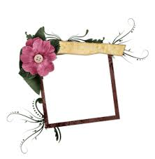
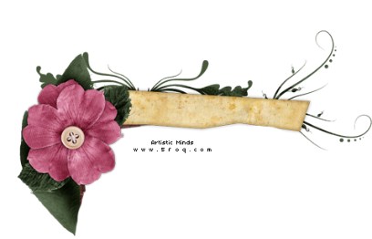
M1
Nice and Tasty

Title. 1b. Let's Order
Objectives:
1: By looking at the picture, Ss will be able to:
a: Explain the vocabulary.
b: tick the food and drink that she usually order.
2: listening to the dialogue, Ss will be able to
a: Read & act the dialogues carefully
b: find the mistakes in the picture from the dialogue.

3: understanding the grammar, Ss will be able to :
a- Explain the uses of ( some + any ).
b- Form sentences using ( some + any ).
c- complete the dialogue with some or any

4: Acting a dialogue, Ss will be able to speak and make an order in the restaurant.

Evaluation :
p.10 1: look at the picture then read the vocabulary and tick the food or drink that you usually order
Ex.2 a: listen then read the dialogue.
B: find the mistakes in the picture of orders from the dialogue

Ex.3 p. 11a: give sentences that have " some or any "
b: complete with some or any.

Ex.4 look at the food in ex.1 then act speakwith a waiter to order in a restaurant

Teaching Strategies:

Group work
Think, pair, share
Give one and take one
Read now

Teaching skills:
Speaking
Writing
Reading
Listening

Teaching aids:

Book
Board
Real objects

Home work:

P. 78 – 79
Ex. a – b – c
d – e

" Teaching map "

Teacher's Name: Wafa'a Al-fraidi Principal's name

