Q1: Complete with ( This – That – These – Those ) :
- _________ is a book.
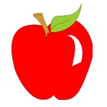
- _________ are pens.
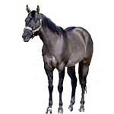
- _________ are apples.
- _________ is a horse
===========================================================================
Q2: Complete with (a - an):
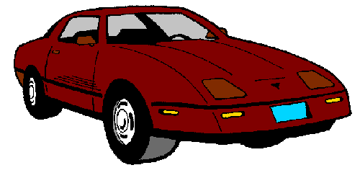
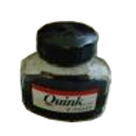
___desk ___egg ___car ___ink
===========================================================================
Q3: Match:
Don’t take photographs. - Don’t use cell phones. - Don’t touch.

______________________ _____________________ _______________________
===========================================================================
Q4: Name 5 things in museums:
______________________
______________________
______________________
______________________
______________________
===========================================================================
T/ Waleed Al sqour Good lock

