Student's Name: ---------------- Class: ------------------ Quiz (1)
=================================================================================
A) Listening:
Listen to the cassette, then choose the correct answers:
1- a- Not bad. b- See you later. c- Good evening.
2- a- I'm fine. b- Have a nice day. c- Not much.
3- a- 0195433677. b- Take care . c- Twenty-three.
4- a- I'm Saudi. b- I'm from Saudi Arabia. c- I'm very well.
5- a- See you tomorrow. b- So-So. c- Great!
===============================================================================
B) Comprehension:
There are two friends, Kamal and Sami. Kamal is a Kuwaiti mechanic . He is working in the garage . But his friend Sami is a teacher . He is from Qatar. He is at school . He is reading a book in the library .
Questions :-
1- Are Kamal and Sami friends ?
---------------------------------
2 – What is Sami`s job ?
---------------------------------
Choose the correct answer ;-
1-Kamal is working in the ---------------.
a- classroom b- garage c- office
2-Kamal is from ------------ .
a- Oman . b- Kuwait c- Qatar
Put ( P ) or ( O ) :-
( ) 1- Kamal is a mechanic .
( ) 2- Sami is Saudi .
Complete :
Sami is reading in the ---------------------.
===============================================================================
C) Grammar:
Choose the correct answers:
1- They [ am – is – are ] students.
2- [ She is – Is she – She isn't ] your teacher? Yes, she is.
3- [ This – These – Those ] girl is a student here.
4- Do you want [ an – a – the ] cup of tea?
=============================================================================
D) Vocabulary:
a- Choose the correct answers:
1- He is very [ busy – hungry –funny ]. He can't wait till lunch break.
2- How do you [spell – live – ride] you surname? A–L–A–H–M– E–D
3- The opposite of active is: [ rude – shy – lazy ].
b- Circle the odd word:
* red – blue – watch – yellow
============================================================================
E) Writing:
Rewrite the following sentence after correcting the mistakes:
this is maha s book
-------------------------------------------

Student's Name: ---------------- Class: ------------------ Quiz (2)
=================================================================================
A) Listening:
Listen to the cassette, answer the following questions:
a- Match the people with the jobs:
1- Tony ( ) a- chef
2- Mr. Baxter ( ) b- bellboy
3- Sam ( ) c- receptionist
b- Write (T) or (F):
( ) 1- Mr. Baxter doesn't work on Tuesdays.
( ) 2- John has a letter for the chef.
================================================================================= B) Grammar:
a- Choose the correct answers:
1-I ( study – studies – studying ) every evening .
2-Ali ( go – goes – going ) to school early .
3- (Do – Does – Is ) you wake up early ?.
4- She will visit her friend (on – in -at ) Sunday evening.
5-My work is ( in – on - at ) the morning .
6- I like ( swim - swimming - swims ).
7- He want to ( play – playing – played ) football today.
8-We ( don’t – doesn’t – isn't ) like black cars.
b- Rearrange the following sentence:
1- loves / she / the Holy Qur'an / reading
-------------------------------------------------------.
==============================================================================
C) Vocabulary:
a- Match the two columns:
1. mop ( ) a. on the phone
2. do ( ) b. shopping at the mall
3. hang ( ) c. the Net
4. surf ( ) d. the floor
5. download ( ) e. information
6. talk ( ) f. out with friends
( ) g. the washing-up
B. Choose a, b or c:
1. Ahmad is the of a magazine.
a. editor b. chef c. bellboy
2. Can I my e-mails on your computer?
a. take up b. check c. interview
3. Ali goes to the mall. He doesn’t like spending his free time there.
a. rarely b. often c. always
4. My always has lunch in the cafeteria.
a. boss b. university c. chat
Good Luck
Student's Name: ---------------- Class: ------------------ Quiz (3)
=================================================================================
A) Listening:
Listen to the cassette, then answer the following questions:
a- Choose the correct answers:
1- The weather is usually ------------------ in Milan at this time of year.
a- rainy b- cold c- warm and sunny
2- The temperature is about -------------.
a- 25ºC b- 22ºC c- 2ºC
3- Daniel has ----------- in his bag.
a- some food b- some books c- T-shirts
4- Who has Daniel's umbrella? Her --------.
a- sister b- aunt c- uncle
b- Write (T) or (F):
( ) 1- The weather today is rainy.
( ) 2- Toby is meeting Daniel at the airport.
================================================================================= B) Grammar:
a- Choose the correct answers:
1-She is ( reading – reads- read ) the Qur'an now .
2- They ( am – is – are) going shopping next Monday.
3- Who ( you are – is your – are you ) English teacher?
4-( Who – who's- whose) pen is this? It's hers.
5- ( Their – Theirs – They ) house is new.
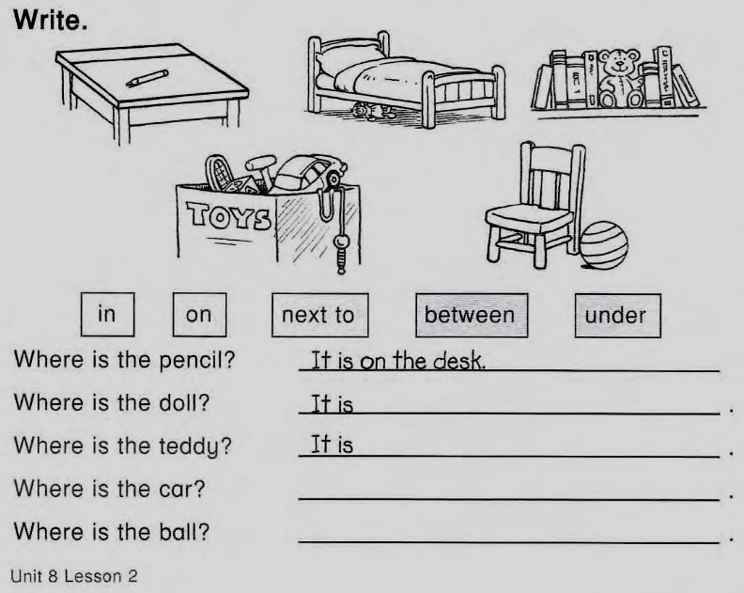
6- There (is – are – be ) 5 bedrooms in my house.

7- Can you see (a - an - the ) sun ?
8- (Is there – Are there – There is ) a garden in your house ?
9- The pencil is ( in – on – under ) the desk.
10- This book isn't ( my – me – mine).
==============================================================================
C. Vocabulary:
a- Match the two columns:
1. air ( ) a. driver
2. bus ( ) b. bank
3. coffee ( ) c. room
4. living ( ) d. conditioner
( ) e. table
b. Circle the odd words:
1- father – mother – son – stadium – daughter
2- winter – cupboard – spring – summer – autumn

c. Write the correct word under each picture:
fireplace – bath – stadium – sofa - drawer

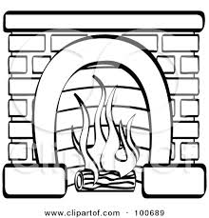

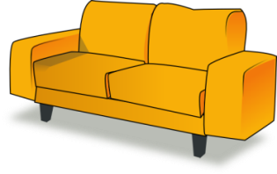

1- 2- 3- 4-

------------- ------------- ------------ -------------

The Best always

Student's Name: ---------------- Class: ------------------ Quiz (4)
=================================================================================
A) Listening:
Listen to the cassette, then answer the following questions:
a- Choose the correct answers:
1- Mr. Hill goes to the doctor because he has -------------.
a- a sore throat b- temperature c- a rash on his arm
2- He doesn't eat strawberries because ----------------.
a- they are expensive b- he's allergic to them c- he doesn't like them.
3- The doctor thinks the problem is ---------------.
a- stress b- headache c- toothache

b- Write (T) or (F):
( ) 1- Mr. Hill doesn't sleep much.
( ) 2- Mr. Hill doesn't ever feel dizzy.
================================================================================= B) Grammar:
a- Choose the correct answers:
1- There is [ a few – a little – many ] salt in the rice.
2- How [ many – any – much ] water do you drink?
3- Those paintings are nice. Let's buy [ they – their – them ].
4- Ali is very fit [ so – because – but ] he goes jogging every day.
5- I like cherries [ but – so – and ] I don't like cherry ice cream.
6- We should [ helping – helped – help ] our parents.

b- Write correct words in the correct category:

Uncountable | Countable

juice– carrots – soup – vegetables

==============================================================================
C. Vocabulary:
a- Choose the correct words:
1– My tooth hurt. I have [ backache – temperature – toothache ].
2- Please I want [ a bottle – a can – a slice ] of pizza.
3- I want a glass of [ water – cheese – soup ].
4- They want to [ sleep – build – receive ] a new shopping centre.
b- Give an example of:
1- a drink: ------------------
2- a kind of main course: -------------
3- a kind of dessert: -------------
4- an ailment: ---------------
C- Circle the odd words:
1- apples – oranges – bananas – salt.
2- potatoes – tomatoes – peaches – carrots The Best of luck

Student's name: -------------- Class: -------- Traveller (2) / Q.(1)
===============================================================================
1- Listening:
A) Choose the correct answers:
1- Matt just came back from -------------.
a- work b- school c- hospital

5
2- Mr. Smith teaches -------------.
a- mathematics b- history c- English
3- Mr. Green doesn't like ------------ students.
a- lazy b- active c- kind
B) Write (T) or (F):
( ) 1- Matt says that his school was nice.
( ) 2- Mr. Green threw a bottle outside the window.
* * * * * * * * * * * * * * * * * * * * * * * * * * * * * * * * * * *
II- Grammar:
A) Choose the correct answers:
1- She [ goes – is going – went ] to Amy's house yesterday.
2- I don't [ eat – ate – eats ] tuna salad.
3- [ Do – Are – Did ] children playing football this week?
4 -Jane went to Europe [ at – on – in ] Winter.
5- There are [ a lot of – much – a little ] bananas.
6- How [ much – a little - many ] meals are there in the day?
7- Salim bought this car three months [ during – ago – before].
8- He used to [ smoke – smokes – smoked].
B) Do as shown between brackets:
1- Sara always got up early on Fridays. ( Correct the underlined word)
--------------------------------------------
* * * * * * * * * * * * * * * * * * * * * * * * * * * * * * * * * * *
III- Vocabulary:
A) Choose the correct words:
1- Barry is really [ fan of – interested – fond of ] in photography.
2- These days people usually [ communicate – allowed – instantly ]through the
Internet.
3- Sam is very [ shy – kind – bossy]. He likes telling people what to do.
4- Many famous people try to be good [beat – role models – clean] for teenagers.
5- I was never [ fond of – display – send ] football. It’s boring.
6- My brother is a very [ lazy – active – confident ] person. He does a lot of
things during the day.
B) Match:

10
1- hold on ( ) a- great
2- Nice on ( ) b- dislike
( ) c- wait
C) Rewrite the sentence using the word in brackets:
1- Alice hates homework. (can't stand)
------------------------------------------------- Good Luck ☺
Student's Name: ---------------- Class: ------------ Quiz (4)
=================================================================================
A) Listening:
Listen to the cassette, then answer the following questions:
a- Choose the correct answers:
1- Lina passed --------------- exam.
a- chemistry b- physics c- Biology
2- Noor took -----------------.
a- business and management b- chemistry c- physics
3- Lina wants to study ------------- at university.
a- medicine b- business and management c- physics
b- Write (T) or (F):
( ) 1- Lina got her exam results.
( ) 2- Noor wants to be a reporter.
================================================================================= B) Grammar:
1- Who did you ( saw – see – seeing ) at the reunion ?
2- Norah [ are – were – was ] terrified after the burglary at her house.
3- He [ buy – buys – bought ] a new car last night.
4- What time [ did – dose – do ] Ali leave yesterday?
5- The exercises of English are [ easily – easiness – easy].
6- She didn't [ stayed – stay – stays ] at home yesterday.
b- Do as shown between brackets:
1- She studied hard to pass the exam. (Ask a question using Why)
--------------------------------------------------
2- 2– Did Ali fail the exam ? ( Give a negative answer )
-------------------------------------------------
==============================================================================
C. Vocabulary:
a- Choose the correct words:
1- Could you write when you at the [ artist – age – century ] of six?
2- [ Look – steal – memory ] out! There's water on the floor.
3- Last year, he wanted to take a new [ technology – modern – course] at
university.
4- Thomas Edison was an American [ scientist – attend – due ].
b- Give the opposites of:
1- fast X ----------------- 2- forget X ----------------
C- Circle the odd words:
1- hiking – sightseeing – degree - camping
2- suddenly – writer – poet – artist
C- Write the correct word under each picture:
scuba- diving / horse riding / skiing / fishing


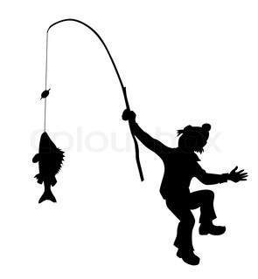

1- -------------- 2- -------------- The Best of luck

