Grammar review models 1+2

Choose :
1- we ( have – has – is ) solved the problem.
2- they ( have – have been ) working all day .
3- have you ( ever – never )been to Dammam?
4- I have ( never – ever ) been to Dammam .
5- She has been sleeping( for – since)3hours .
6-you should ( do – make ) extra effort to improve .
7- ( do – make – get ) your math project as groups.
8- I regret wasting time. I ( should not – should – ought ) waste time .
9- mix eggs ( with – from – to ) a fork .
10- mothers protect their children ( with – from – by ) dangers .
11- If a day ends ,a night ( starts - will start – would start )
12- If I lived on the moon, I ( will miss - would miss - missed ) the planet earth .
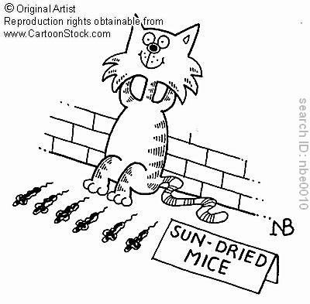
13- if you tell the truth , you ( will – would ) not be punished .

Correct the mistakes found in each sentence :
1- Muslim scientists found the base for many invent.
……………………………………………………………………………….
2-you should replacement the broken dish with a new one .
………………………………………………………………………………..
3- At this time tomorrow I will be travel to Makkah .
………………………………………………………………………………..
4- By 2020, scientists will make new discoveries .
………………………………………………………………………………..

