المملكة العربية السعودية |  | مكتب التربية والتعليم بوسط جده
وزارة التربية و التعليم
الإدارة العامة للتربية و التعليم

اسئلة اختبار الفصل الدراسي الاول للعام الدراسي 1436/1437هـ
اسم الطالب |  | رقم الجلوس

المادة | لغة انجليزية | الصف | الثالث | الزمن | ساعتان | التاريخ | / /1437هـ
Q1)Choose the right answers :
1) We are …………… football .
d) played | c) playing | b) plays | a) Play
2) Where ………….. he live ?
d) done | c) doing | b) does | a) do
3) Hassan can run …………... than Ameen .
d) fasting | c) fastest | b) fast | a) faster
4) What did you …………… ?
d) cook | c) cooks | b) cooking | a) cooked
5) I …………… smoke .
d) user to | c) uses to | b) using to | a) used to
6) Ali is the boy …………… we met in the school .
d) who | c) what | b) where | a) which
7) Jeddah is the place …………… I live .
d) why | c) which | b) when | a) where
8) If he …………… a new car , he will drive to Abha .
d) buying | c) buyed | b) buys | a) buy
9) I …………… tried so hard .
d) are | c) is | b) has | a) have
10) Ali has …………… to Taif .
d) do | c) gone | b) went | a) go
11) I have known Ahmed …………… 2 years .
d) am | c) are | b) for | a) since
12) I have been in this school …………… 1434 H .
d) is | c) are | b) for | a) since
13) ............... Picasso and Van Gogh lived in France .
d) Either | c) Neither | b) All | a) Both
14) …………… friends heard the noise .
d) all | c) either | b) neither | a) both
15) I …………… Ahmed .
d) were | c) am | b) is | a) are
16) A ruler is about 30 …………… long .
d) meter | c) gram | b) kilometers | a) centimeters
17) He is Ahmed . …………… he ?
d) is | c) isn't | b) are you | a) are
18) The missing letter in _nglish is
d) N | c) L | b) S | a) E
19) The missing letter in foo_ball is
d) t | c) k | b) m | a) s
20) The missing letter in readin_ is
d) x | c) g | b) u | a) s
21) The missing letter in sta_ues is
d) q | c) f | b) t | a) m
22) The missing letter in friendshi_ is
d) p | c) w | b) d | a) u
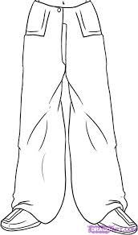  26) | 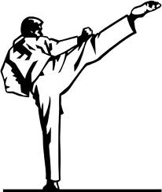  25) | 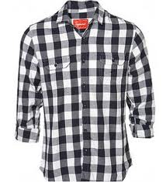  24) | 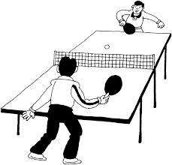  23)
- Watch  - Sun glasses  - Jacket  - Baggy trousers | - Karate  - Basketball  - Table tennis  - Golf | - Shirt  - Dress  - Hat  - Belt | - Karate  - Basketball  - Table tennis  - Golf
30)  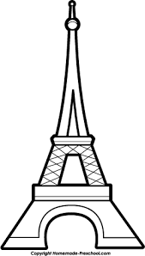 | 29)   | 28)   | 27)  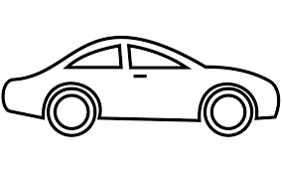
- Tower  - Store  - Supermarket  - Mall | - House  - Office  - Mosque  - Pyramids | - Bridge  - Desk  - Book  - Printer | - Train  - Air plane  - Car  - Ship

(2)- Match

a)ow | 1)exp ( )
b)est | 2) re ( )
c) act | 3) sugg ( )
d) lain | 4) all ( )
e) age | 5) encour ( )

Q2)Match:

Q3:After reading the passage, put ( T ) and ( F ):

My Family’s Jobs
My father and uncle have great jobs. My father is aphotographer. He works in an advertising firm. He takesphotos for different customers. He works Saturday toWednesday. My uncle is a doctor. He works in the hospital.He helps sick people. And he works all the time.

1-The passage is about my family’s jobs. ( )6-he works on Friday . ( )

2-My father and Uncle have a bad job ( )7-My Uncle is a doctor .( )

3-My father is a teacher .( )8-he works in the school . ( )

4-My father works in an advertising firm( ) 9- He helps sick people . ( )

5-he takes photos for different customers .( ) 10-he works all the time . ( )

Good luck

