Unit 6

1- How many rooms are there in your house?
…………………………………………………………………………………………………………………………………………………………………………
2- Where do you live?
…………………………………………………………………………………………………………………………………………………………………………

A- What is the place :
( kitchen– house –garage –bedroom –mosque )

……………………… ………………………………. ………………………….. ………………………………

B- Choose the correct answer:
1) There ( is –are ) 3 bathrooms upstairs.
2) There ( is –are ) a kitchen upstairs.
3) There ( is –are ) a bedroom downstairs.
A barber's shop is a place where you ( cut –clean ) hair. 4)
A mosque is a place where you ( pray –buy food). 5)
6) A ( garage –grocery ) is a place where you park cars.
7) We ( sleep –sleeps ) early.
She ( like –likes ) our food. 8)

I ( eat –eats ) breakfast. 9)
The cat ( drink –drinks ) milk. 10)

C- Answer:
1- Where is the girl?
……………………………………………………………………………………………………………………………………………………………

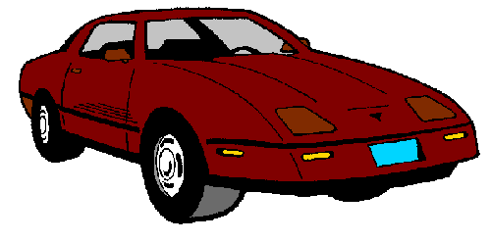
2- Where is the car?
……………………………………………………………………………………………………………………………………………………………

D- Match words in (A) with the right number from (B):

1- bed | ( ) living room
2- shower | ( ) bedroom
3- stove | ( ) bathroom
4-armchair | ( ) kitchen
 | ( ) dining room

