4-What`s the weather like?

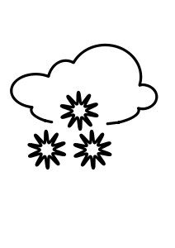

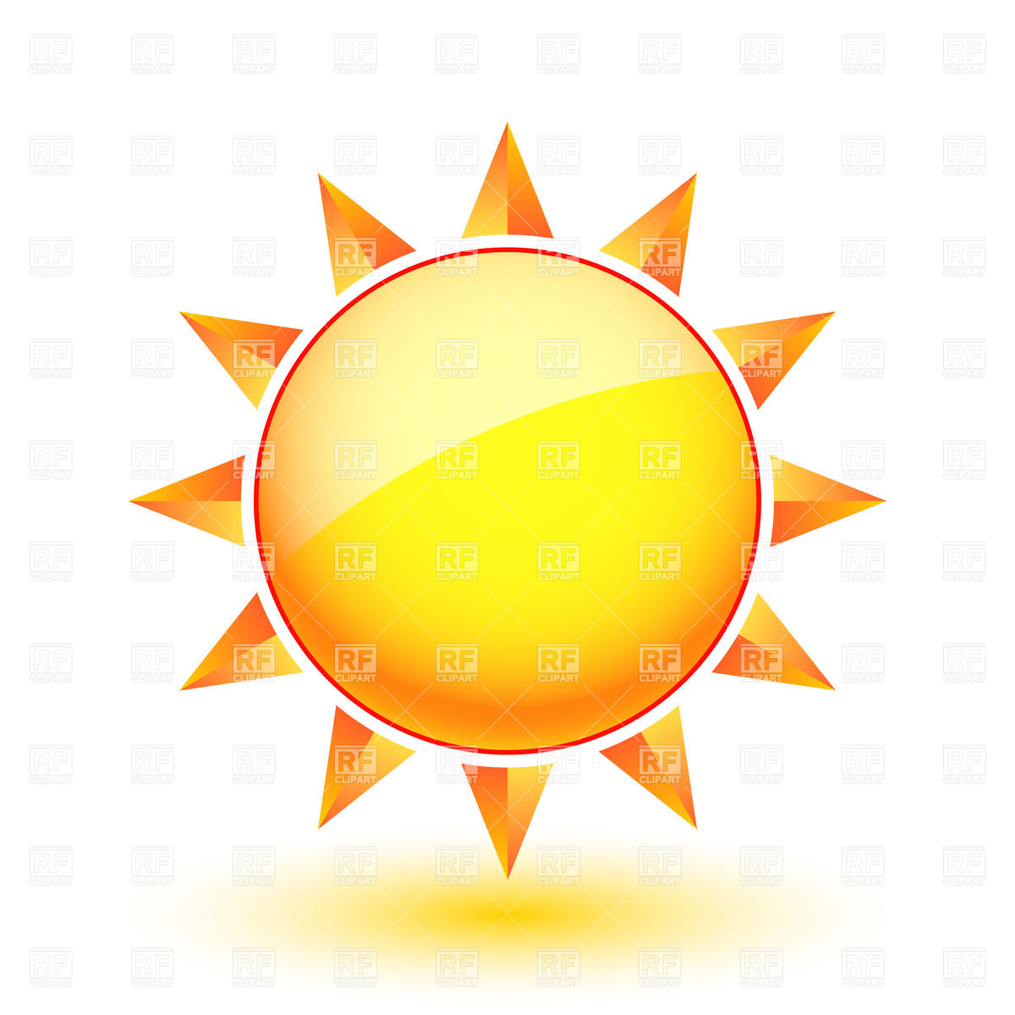

cloudy sunny windy and rainy snowy




foggy cold hot

*Grammar:

1- Present progressive

I Am

She
He is + v ( ing )
It

They
We are
You
ملاحظة:
كلمات تدل على المضارع المستمر now –
this day this week ..etc – tomorrow – today

