
Kingdom of Saudi Arabia
Ministry of Education 2ndGrade
second term
Year. 1433/1434

اسم الطالب رقم الجلوس

- Read the following passage and answer the question :
A-Answer the question :
Ahmed is very happy because his family can go on holiday this year . Last year they couldn’t go anywhere because they were very busy . This year they decide to go to Egypt because there are many interesting things there . His mum can’t go by plane because she is scared of flying . They will have to go by the car .they will visit the pyramids and the Sphinx .They will go to the sea in Alexandria .

3

- 1- why Ahmed is very happy ? ………………………………………………………..
- 2- where do they decide to go this year ? ……………………………………………..

B- complete :
3- His mum can’t go by plane because ……………………………………….. .

C : put ( T) or ( F)

4- they will go to the sea in Alexandria . ( )

6
- 2 -Match the words with their correct picture:
1-sleepy 2- fan 3-newspaper
4- tyre 5-motorbike 6- stones


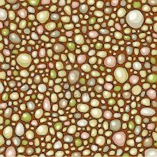
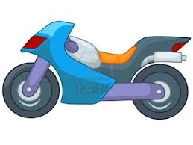
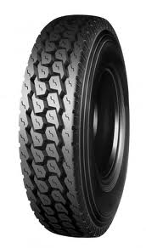
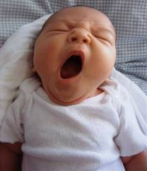
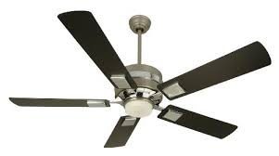

Grammar :
Choose the correct answer :

1- They are ……………( going to - will ) destroy that rubbish tomorrow .
2- I can’t stand ………..(waste – wasting ) food.

3-You ……….( mustn’t - couldn’t ) climb up the tree , it is very dangerous .

4- The car …………… ( clean – is cleaned ) by Ali every day .

Do as shown in brackets :
5- I am going to paint the door tomorrow . (will)

6
…………………………………………………………………………………
6-She tidied the room yesterday . ( passive)
......................................................................................
Choose the correct word to complete the sentences :
Shopping centre - inventor- trap- breathe

4
1-The …………makes new things .
2-This ………. Will help us to catch the mouse .
3-Let’s go to the ……………….. I need a new hat.
4-Humans …………..in oxygen .

Re arrange the following :
1- shouldn’t / we/water /waste/.

2
………………………………………………………
2-is /at /He /reading/English/good.
……………………………………………………………………………

Dictation :

4
m o n - y fl-wer ro - d - hrow

Handwriting :

We should be careful when we cross the road .

5

