1- Comprehension
Read the passage then answer the questions below :
Islamic Relief Worldwide is an international humanitarian and development charity. Islamic Relief Worldwide was founded in 1984. Islamic Relief Worldwide helps the poorest people in the world at times of natural disasters such as floods, drought and eruption of volcanoes. Another important , part of the work of Islamic Relief Worldwide is to run development projects which help people to work and look after themselves. People raise and give money to Islamic Relief so that it can do its work .
A - Answer these questions:
1- What is the article about ?
.....................................................................................................................
2- When did Islamic Relief Worldwide found ?
.....................................................................................................................
B - Choose the correct answers :
1- Islamic Relief Worldwide is an international humanitarian and development ( company - charity ) .
2- Islamic Relief Worldwide helps the ( poorest - richest ) people in the world .
**********************************************************
2-Grammar:
A- Do as shown between brackets :
1- They started to play football . They are still playing football .
....................................................................................................................................
2- She started to cook the dinner . She is still cooking her dinner.
........................................................................................................................................
( make a sentence using present perfect continuous )
3- Hind watched TV . She ate her dinner .
........................................................................................................................................
( make sentence using While )
4- The case is damaged . It happened at the airport .
........................................................................................................................................
( make apologies )
B- Choose the correct answers :
1- They ( has - have - had ) been writing their homework.
2- She has been ( read - reads - reading ) a novel .
3- On ( arrive - arrived - arriving ) home . They found Ali .
4- After ( see - saw - seeing ) the movie . He went to bed .
***************************************************************************
3-Vocabulary :
A-Mach the words with the correct pictures :
( carpet - damage - apology - sledge - motor )
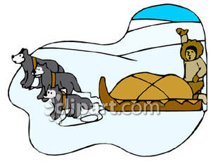


.......................................... ............................................
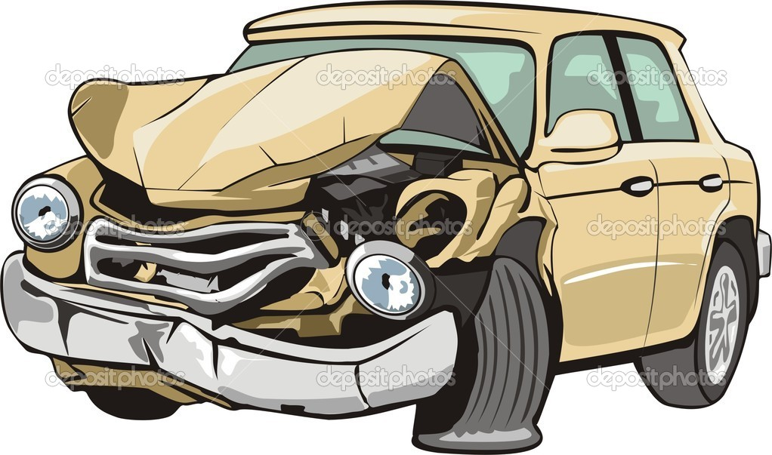
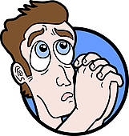

.................................. .........................................
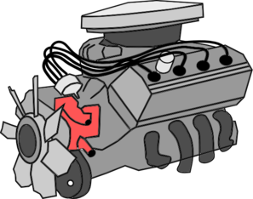

.................................................

****************************************************************************
4- Spelling:
A - Choose the correct letters:
1- humanitaria.......... ( n – k – b ) 2- .......ociety ( l – s – r )
3- expe......ition ( g - m – d ) 4-.......rap ( n – t - m )
5- re.......ponsibility ( s – k – l ) 6- since.......e. ( l – p – r )

