Write the correct word under each picture :
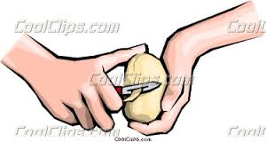
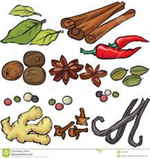
( add /measure/ paste / peel/sauce / spice / turn down )
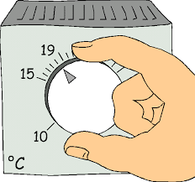
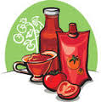
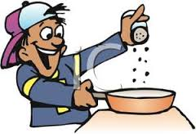
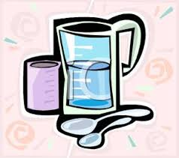
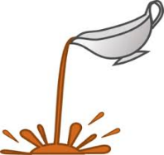

………………… …………………… …………………… …..………..…… ………………… ……………… ……………..
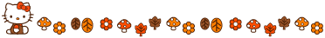
Choose the correct article :
1-Close ( a/ an / the ) window , please .
2- Pasta is ( a /an / the ) delicious meal .
3- Add ( a / an / the ) orange juice to the dessert .

Circle the direct object and Underline the indirect object :
1- Give me the pen .
2- She lend him a book .
Fom a question &answer :
1- I would like a cup of tea .
……………………………………………………………………….?
Yes ,……………………………….. No, …………………………………..

E.T :Lamia Al-Fadil

