

The Final Exam for 2st Grade
Second Term
1435 - 1436 AH
Time: Two Hours

المملكة العربية السعودية
وزارة التربية والتعليم
الإدارة العامة للتربية والتعليم بالطائف
مجمع عتاب بن اسيد
الصف الثاني متوسط

 |  | Corrected by
30 | Thirty marks | Total marks

الاسم /Name: …………………………………………………………………………………………………….........…………………….

Q.1 –
Read the passage and answer the questions below:
The Last Prophet Mohammad (PBUH) Prophet Mohammad (PBUH) was born in Makkah . His Father, died before he was born. His mother, died when he was a child of 6 years old. He lived with his grandfather Mohammad (PBUH) worked as a shepherd. He was always honest and people called him “AlSadiq AlAmeen “. He started spreading the message of Islam in Makkah. After fourteen years he move to Al Madinah. The people of Al Madinah supported him a lot . He died in the year 11 of AL Hijra in Al Madinah .
A- Choose the correct answer:
1- Prophet Muhammad (peace be upon him) was born in...............
a- Makkah c- Riyadh d- Madinah
2- A shepherd is a person .................
a- who teach a children b– who looks after a sheep c- who drive a cars
3- His mother, died when he was
a. 10 years old. b. 12 years old. c. 6 years old.

B. Put ( √ ) or ( X ) for each statement:
1- The people of Al Madinah supported Muhammad (PBUH) ( )
2- He died in the year 15 of Al Hijra in Al Madinah ( )

Q.2-

A- Choose the correct words:
1- What is ( your – you – I ) phone number.
2- There ( is – are – am ) many cars .
3- Sami ( is - was – were ) a football player last year.
4- Whose are the pens ?
a- they are Ali's . b- they is Ali's . c- it is Ali .

تابع خلف الصفحة
Q.3-

A. Write the correct word under each picture:
Classroom - Closet - Teacher - Jacket
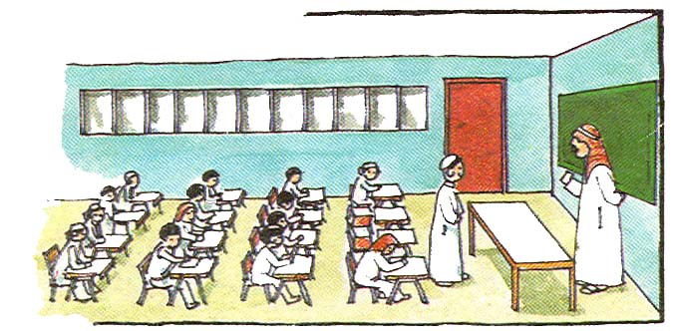
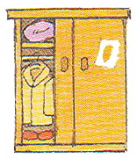
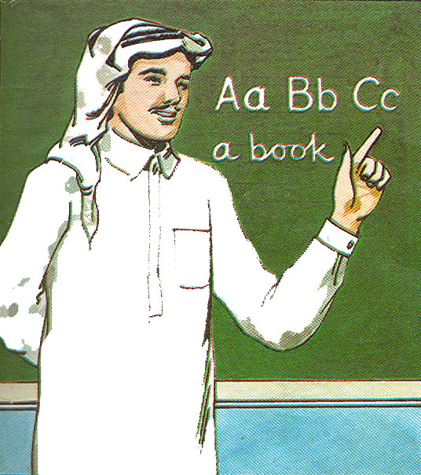
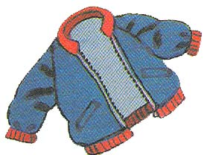

…………….…………………………
……………………………………
……………………………………
……………………………………

B - Match column A with column B

B |  | A
My favorite hobby is reading . |  | 1- What is your name ?
My name is Essam . . |  | 2- How old are you ?
It is twelve - thirty . |  | 3- Where were you born ?
I was born in Jeddah . |  | 5- What is your favorite hobby?
I am 14 years old . |  | 6- What time is it ? 12:30

Q.4-
A ) Write the missing letters: ( w , t , e , a , i , m ,o ,r )
week__nd al__ays
somet__mes gree__ing
ye__rs na__e
ca__ bo__k

B . Copy the following sentence:
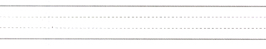
Everyone have to work hard to live a better life.

إنتهت الأسئلة With My Best Wishes

