Name : _____________________ Class : 2/____ 2nd Grade 2nd Term 2nd Term
10
Quiz Unit 1
Super Goal 4

- Grammar :
- Make a Suggestion and give a Respond: (go bowling ) -----------------------------------------

Accept : --------------------------------------- Refuse : ------------------------------------------------

2. Correct the verb : a/ My friends ( goes ) fishing ----------------------
b/ Why doesn’t he ( going )to the doctor. ----------------------
c/ Sara ( have )to buy a laptop. ----------------------
d/ They ( have ) to work hard yesterday ----------------------
e/ you should ( helping ) your mother. ----------------------
- Choose the right answer :
- You should ( prays - pray - prayed ) on time.
- Women have to ( cover - covering – covered ) their faces.
- Let’s go ( ride - rides - riding ).
- Rana ( go - going goes ) shopping every Friday.
- Why ( don’t - didn’t - doesn’t ) we clean the class ?
===========================================================================================
- Vocabulary : 1. Match synonyms ( meanings ):
2. Give opposites :
a. accept # ……………………….
b. agree # ……………………
c. irresponsible # …………………..
4. necessary # ………………………
1. nag father and mother
2. schedule trash
3. Parents pocket money
4. garbage disappoint
5. allowance list
6. Let down

- Give examples of :
Chores / 1………………………………………….. 2. ……………………………………………………
Activity/ 1. ……………………………………….. 2. …………………………………………………..
- Match words with pictures :
Hiking - surfing - laundry - clean --mow the lawn - garbage
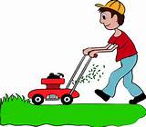

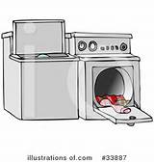
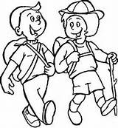
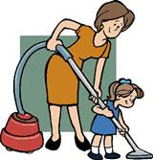

==============================================================================================
Orthography. Fill in the missing letters /
1. s__imming 2. sk__ing 3. s__rfing
Best Wishes 
T: Iman + Nawal

4.. d__shes 5. allowa__ce

