1) Techno is a short form of …………………………….. . It means
2D) Techno world Page 28 – 29 Date / / 1436
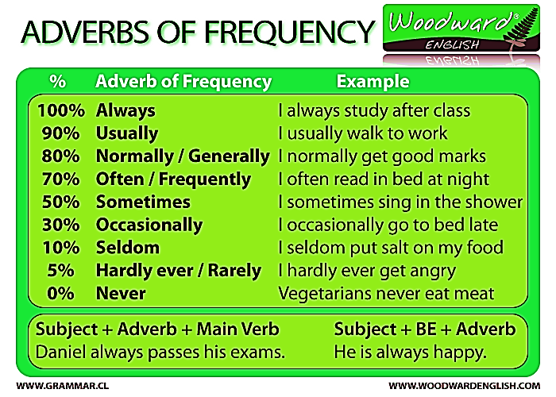
Do you use technology? Give examples. Determine how many times do you use it?
Modern techno | adverb frequency | Percentage
 |  | % 100
 |  | % 80
 |  | % 60
 |  | % 40
 |  | % 20
 |  | % 0
What do the following terms mean ?
SMS = …………………………………………………………………………………………………………………………………….
Net= …………………………………………………………………………………………………………………………….
download= ……………………………………………………………………………………………………………………………
www= …………………………………………………………………………………………………………………………………..
USB=……………………………………………………………………………………………………………………………………….
2) In groups, ask your colleague how often do you ………………………….?
…….. check your email ……… play computer games ………. use whats app ……… watch TV …….. download programs ……… surf the net ……… go shopping ……. read news ……. Hang out with friends ….. go to gym ……. fish …….. listen to English radio ……..
What is the correct position of adverbs of frequency ?
3) Each group, choose a pair to act out
4) look at the text in section 4 …….
What do these pictures mean? …………………………………… ………………………………………………………..
In general, how often do you use them?.....................................................................................
Give example ………………………………………………………………………………..………………………………………
What is it about ? …………………………………………………………………………………………………………………..
Now, answer the questionnaire (survey, assessment, analysis). Try to guess the meaning of unknown words.
No wrong answers. The aim is to make a clear idea about your habits
Word | Meaning | Word | Meaning
variation of spoken pitch
Yes/no questions
Raising
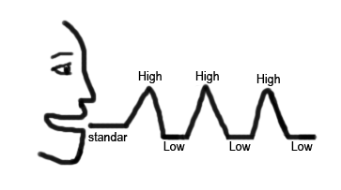

Intonation
Falling
Best wishes. By Reyadh Almalki

Wh- questions
1) What do the people do ? ………………………………………. Where ? ………………………
2E) At the gym Page 30 – 31 Date / / 1436
Give synonyms ………………………..……………………….………………………………………………..
When do people do something like that ? …………………………………………………………..

Match the picture with the correct phrase.
Sentence vs. phrase

2) What is type of the text? Is it a report or an interview ?...........................
Who is the interview about ? ……………………………………..
What is the reason make the reporter interviews him ?.............................................................
Give synonyms ……………………………………………………………………………………………………………………..
Give example of people like Salman Malik. …………………………………………………………………………..
In groups, read the text & match the paragraph with the suitable question.
1 ……………………. 2 ……………………. 3……………….. 4…………………..
In groups, answer the following questions. Underline the answers in the text.
How often does Salman go to the gym? ………………………………………….……………..…..
What kind of food does he eat? ……………………………………………………………………..
Does he have much free time? ………………………………………………………………………
Is he a full-time karate teacher? …………………………………………………………………….
When does he teach children karate? ………………………………………………………………...
How does he spend his free time ? …………………………………………………………………..

Read the text again, answer the questions bellow. Underline the answers in the text. (p 31)
4) In groups, ask & answer each other about free time activities.
Demonstrate the dialogue with a group of students.
5) What is the correct order of English sentences? .....................………………………………………………………………..
Do activity in your book page 31

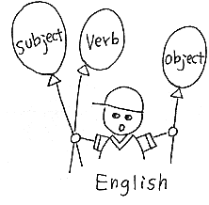
Best wishes. By Reyadh Almalki

