Name :………………………………………………………………………… Class : 2/…………

___________
10

Test Module 1
1)Write the correct word under the correct picture:

shy - classroom - sponge- boots - telephone

 | 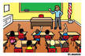 |  |   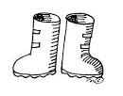

2) – Cross out the odd words : -
1. Maths-Geography-PE-Fridge

3) -Choose the right answer :
1-They(work– works–worked)everyday.
2-Amal (is-are–am) listening to the radio at the moment.
3- I love (goes - go– going)to football match.
4-Paul watches TV( on - in –at)7 p.m.

4) Do as shown between brackets:
Derk goes to the park. [ Use the never ]
------------------------------------------------------------------
5)Write the missing letter :
1- coo__er 2- La___y 3- h___t 4- chemi___try

