Module ( 4 )
Name:…………………………………………….. Class:…………..
1} Speaking:
A) Do you live in a small town or a big city ?
………………………………………………………………………………..
B)What is the name of our galaxy ?
………………………………………………………………………………..
C) How many planets do we have in our solar system?
………………………………………………………………………………..
D) What is the smallest planet ?
………………………………………………………………………………..
E) What is the biggest planet ?
………………………………………………………………………………..
F) What is the hottest planet ?
………………………………………………………………………………..

2} Reading Comprehension:
3} Vocabulary
A)Write the correct word under each picture:
car park - mosque - bridge - moon - solar system
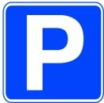
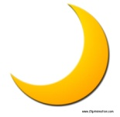
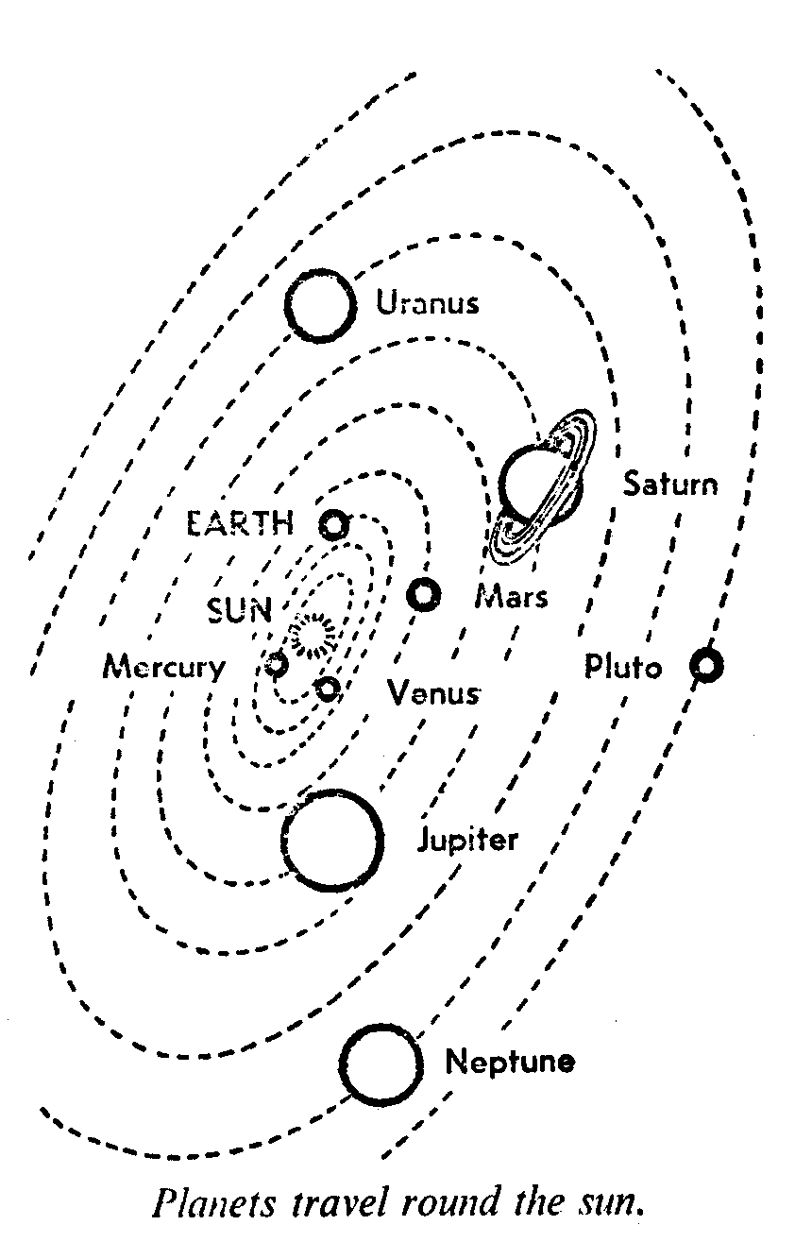
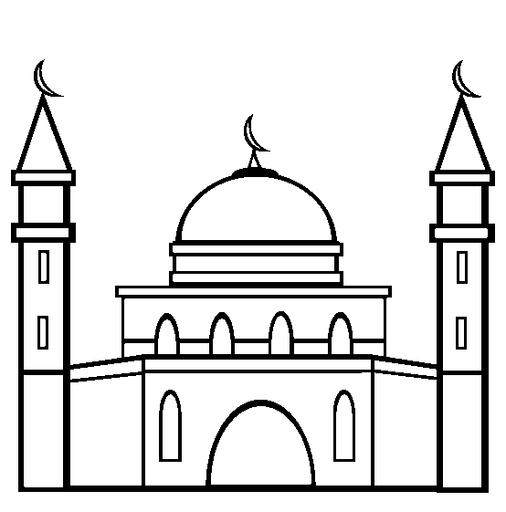

…………………….. ………………………. ……………………….. …………………………

B) Put the correct word in the correct space:
farm - Earth - library - straight - supermarket - tree house

1- Our planet is the …………………….
2- I can buy fruits from the …………………..
3- you can borrow a book from the ……………………
4- If you want the hospital, go ………………… on and turn right.
5- My grandfather has a lot of animals in his………………………...

4} Grammar

A) Choose:
1- The chemist's is ( behind - between - next to ) the library and the post office.
2- I want to travel ( from - in - to ) Riyadh to Jeddah.
3- Adel is ( fast - faster - the fastest ) than Ahmad.
4- Maha is ( beautifulest - more beautiful - the most beautiful ) girl in the class.
5- You have ( bad - bader - worse ) marks than Lara.

Do as shown between brackets:
1- Borrow / your / book ( make a polite request )
…………………………………………………………………………………………………………………..
2- help / you ( make an offer )
…………………………………………………………………………………………………………………..3- go / my friends ( ask for permission )
…………………………………………………………………………………………………………………..

4- good / …………………… cheap / …………………….. comfortable / ………………………
( write the comparative form of the adjectives)

5- far / ……………………… expensive / ……………….…….. tall / ………………………
( write the superlative form of the adjectives)

5} Dictation:
1-Complete the spelling of the words under the picture
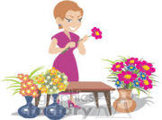
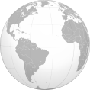

f__ori__t's ea__th

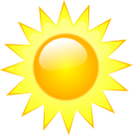
2- Rearrange the letters to form the correct word under the picture.


t s r a u n s
…………… …………….

6} Writing:
Write a paragraph about " Buraidah " by answering the following questions.
1- Where do you live?
2- Where is this city?
3- What are some of the most interesting places ?
4- What do you think of this city?
……………………………………………………………………………………………………………………………………………………………………………………………………………………………………………………………………………………………………………………………………………………………………………………………………………………………………………………………………………………………………..……………………………………………………………………………………………………………………………………………………………………………………………………………………………………………………………………………………………………………………………

7} Listening:
Tr. Haifa Almogbil

