
___
48

Kingdom of Saudi Arabia
Ministry of Education
Tabuk Educational Zone
The 1st Intermediate school

The Final Exam
Second term
1435-1436 H
Third grade
Time:2 hours
Pages NO.:4

اختبار كامل المنهج
for 3rd Grade intermediate (1435 / 36 A.H.)
… Seat No: …………........class:............................................................... : s nameۥStudent

(( اللهم لا سهل إلا ما جعلته سهلاً وأنت تجعل الحزن إذا شئت سهلاً)).

Checked by | Reviewed by | Corrected by | Marks by  writing | Marks by  NO. | Question’s No.
 |  |  |  |  | Question 1
 |  |  |  |  | Question 2
 |  |  |  |  | Question 3
 |  |  |  |  | Question 4
 |  |  |  |  | Question 5
_______  48 |  |  |  |  | TOTAL

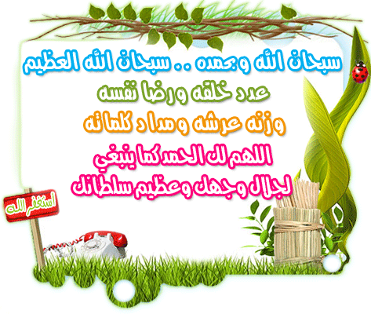

( 1 )

10
I- Composition
Q1: Write an e-mail to your friend to apologize that you're busy:
[asked – math homework – sorry - because ]
………………………………………………………………………………………………………………………………………………………………………………………………………………………………………………………………………………………………………………………………………………………………………………………………………………………………………………………………………………………………………………………………………………………………………………………………………………………………………………………………………

********************************************************************************************

10
II- Comprehension
Q2: Read the following passage then, answer the questions:
Mrs. Sara often spends too much money on clothes. She does not need new clothes, but she loves buying them . Yesterday she saw a beautiful coat in a shop window . She went in and put it on . It was just the right size, but it was very expensive . Mrs. Sara did not have enough money ,but she took the coat home and showed it to her husband . He liked it very much , but he did not like the price. His wife gave him a bill for 2000 RS.
A- Answer the following questions:
1- Does Mrs. Sara often spend money on clothes?
……………………………………………………………………………………………………....
2- What did she see in a shop window yesterday?
………………………………………………………………………………………………………..
3- Was it too small ,too large ,or just the right size?
.............................................................................................................

B- Choose the correct words:
1- Her husband did not like
a- the color of the coat b – the price of the coat.
2- The coat was very
a- expensive b- very cheap .
C- Put ( T  ) or ( F  ) :
1- Mrs. Sara left the coat in the shop ( )
2- Mrs. Sara does not need new clothes , but she loves buying them( )

************************************************************
( 2)
III- Grammar

12
Q3: A- Choose the correct answers :
1- She ( am - is - are ) speaking to another student .
2- Omar really hates ( getting - get – got ) angry .
3- The country ( has - have - had ) changed .
4- Fatimah ( watches - watching - watched ) TV in the evening.
5- Speak politely to a stranger by ( use - used - using ) sir or madam.
6- Nasser is the boy ( who - where - which ) became the first on his class .

B - Do as shown between brackets :

1- He / drinking tea /prefers /to coffee. ( rearrange)
...............................................................................................
2- a)- become ............................. b)- do ............................
( write the past participle of the verbs )

3- Could you switch off the air-conditioner ?
.....................................................................................
( Accept the request )
******************************************************************************

10
IV- Vocabulary

Q4: A- complete the table:

Verb | sport | person
box | ........................................ | .......................................

B- Put the right words under the right pictures:
diver - around – doctor – over - teacher

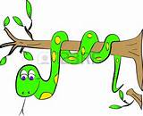


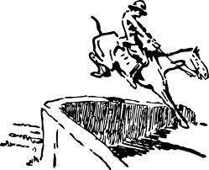
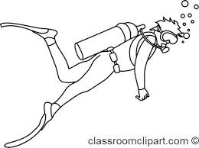

………......…… …………...…… .......................... ………..………
( 3 )

C- Write the correct words :
expression – stranger – madam - mistake - grammar

1- the look on a face ……………………………………………
2- if something is not correct , it is a ……………………………………………
3- we do not know this person ……………………………………………
4- a formal way to speak to a woman ……………………………………………

***********************************************************************************************

V- Spelling

6

Q5: A- Write the missing litters :

1- leathe………… [ s – r- o ] 2- ……… etal [ m – g – e ]
3- ………lastic [ i – j- p ] 4- stee ………[ o – l – x ]

 | 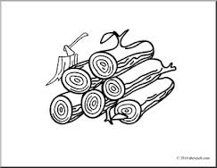 | 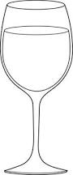 | 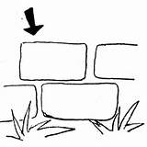
bobir  paper | wood  weid | jlac  glass | brick  prook
B- Choose the right spelling :

***********************************************************************************************
The End.
With our best wishes
Your teachers : .....................

( 4 )

