
Revision Unit (4 )
My Name …………………………………………………………………………………………………………………………………………..

Q 1: Write the correct word under each picture :

( housewife - husband - dictionary - paints - married - ruler – raincoat- cloudy - rainy - foggy Sultan - temperature - surgery - medicine - internet )
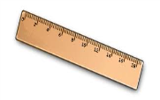








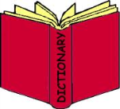
…….. ….….. …..… ……... ……… …….. …….. …….
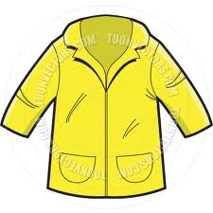






……… ………. ……… ….…. ……… ..…..… ………

Q3: Choose :
1- When ( was – did ) your last trip ? .
2- When ( do – did ) they close the market ?
3-She ( watch – watched ) T.V an hour ago .
4- They ( visit – visited ) her friends yesterday .
5- Layla is ( fast – faster ) than Reema .
6-My bag is ( colourfuler – more colourful ) than Nada's .
7- Jack is ( interested – interesting ) in French .
8- Reading stories is ( exciting – excited ) !



Mrs: Lamia

