Name :……………………………………………………………………… Class : 2/…………

___________
10

Test Module 2
1) Write the correct word under the correct picture:

underground - helicopter - go hiking - donkey - sailor

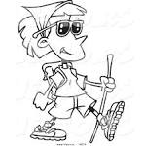 | 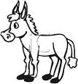 |  | 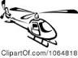

2) – Choose the right opposite : -
fast - safe - cheap

- Expensive # ……………………
- Dangerous # ………………………….

3) - Choose the right answer :

1- Last summer we ( go – goes – went ) on a cruise around the Mediterranean .
2-She ( aren’t - can’t – couldn't ) speak Spanish when she was young.
3- He is talking to you. Listen to ( him - she – they ) .
4- They ( were - is – are ) at home yesterday.
4) Do as shown between brackets :
1-fast …………… 2- slow …………….. [ Write the adverb ]

3- study ………….. 4- do …………… [ Write the past simple ]

