Write the correct word under each picture :
( brush /argue/ housework/toothache/ once / twice )

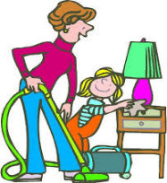
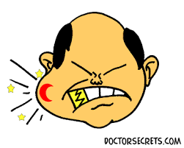




………………… …………………… …………………… …..………..…… …………………… …………..………

Choose :
1-How (much / often / many ) do you watch T.V ? Twice a day .
2-I( read / reads / reading ) books every day . I know ( read / reads / reading ) is nice .

Form a Question with How often ….. :
1- She cooks twice a day .
……………………………………………………………………………

Rearrange :
1- often / do / How / sleep / a day / you
………………………………………………………………………………..….?

E.T :Lamia Al-Fadil

