

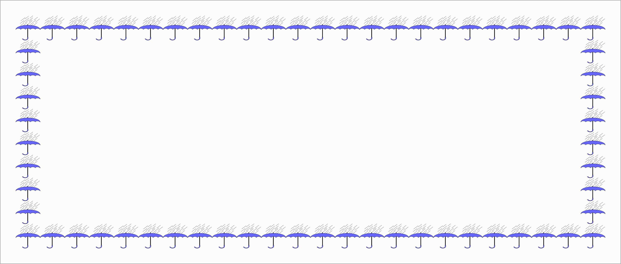
English working paper
Name:
.......................
Module: 1
Lesson:1
Classroom:
........................
Activity:
.......................
Complete these sentences:
1- Look! It ________ (snow). We are going to have a white Christmas.
2- They ________ (usually/travel) to the mountains, but this summer they ________ (travel) to the beach.
3- Bob _________ (watch) the news on TV every morning.
4- I have to go now. It _________ (get) dark.
5- Online courses _________ (require) self-discipline.

Complete these sentences:
We _____________ (see) John and Susie next weekend.
What _____________ (you / think) about the war in Iraq?
She _____________ (have) a headache.
It _____________ (be) cold today.
They _____________ (not / have) a car

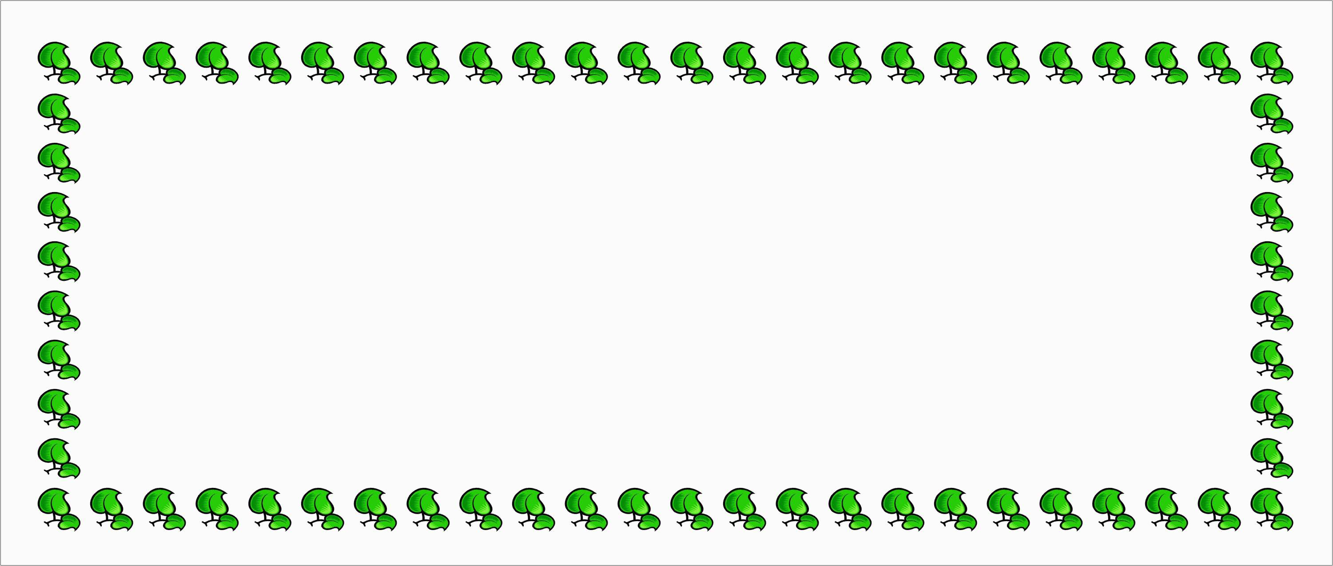

English working paper
Name:
.......................
Module: 1
Lesson: 2
Classroom:
........................
Activity:
.......................
2- __________will you visit her? Tomorrow

1- _________traveled with you ? Ahmed

3- __________do you go? I go to the market.

Complete:
Complete the questions:
1- "How long does it take to get there?"
Do you know______________________________

2- "Where's the station?"
Can you tell me ___________________________

3- "What did Ahmed do?"
Could you tell me ___________________________


English working paper
Name:
.......................
Module: 1
Lesson:3
Classroom:
........................
Activity:
.......................
Write a paragraph explaining why you want to learn English.

______________________________________________________________________________________________________________________________________________________________________________________________________________________________________________________________________________________________________________________________________________________________________________________________________

Complete with the past simple:

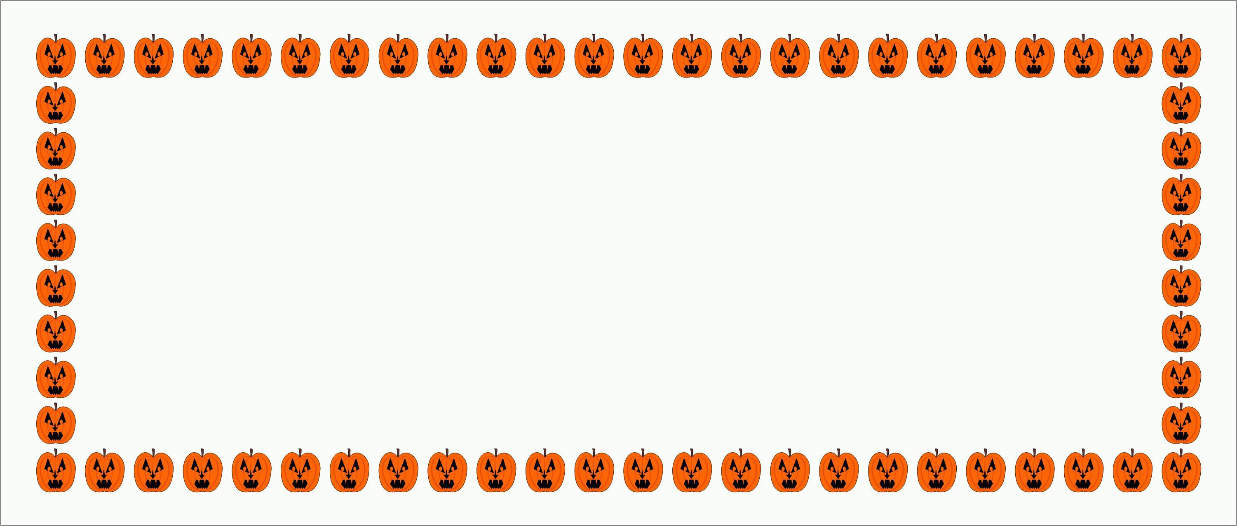
English working paper
Name:
.......................
Module: 1
Lesson:4
Classroom:
........................
Activity:
.......................

He used to ( read – reading ) several books a month but he doesn’t have time any more.

I'm afraid I'll never get used to (live – living) in this place. I simply don’t like it

They (used to – get use to) travel by plane.
Complete with the past simple:

- We __________(buy) a new car last year.
- Where ___________(you/ teach) before you came here?
- He ___________(not/ think) that he was right.
- _____________(she/ swim) in the sea last year?
- He ___________(try) to lift the box but he couldn’t


English working paper
Name:
.......................
Module: 1
Lesson:5
Classroom:
........................
Activity:
.......................
Your friend wrote a letter to you to tell you that he'll visit your city. Write an e-mail answering your friend telling him where and when you will meet him.

_____________________________________________________________________________________________________________________________________________________________________________________________________________________________________________________________________________________________________________________________________________________________________________________________________________________________________________________________________________________________________________________________________________________________________________________________________________________________________________________________

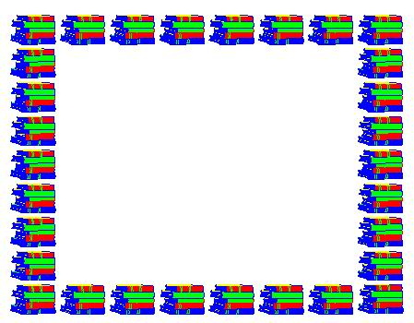

English working paper
Name:
.......................
Module: 1
Lesson:6
Classroom:
........................
Activity:
.......................
English working paper
Name:
.......................
Module: 2
Lesson:1
Classroom:
........................
Activity:
.......................
Choose the correct answer:
Don’t turn (on – off) the light. I need it.

Put (on – off) the jacket; it's very cold outside.

Please, turn (on – off) the light. We'll go out.

If you want to succeed, you must keep (on –off) trying
Choose:

While she (drove – was driving) her car, she saw an accident.
When the post man (arrived – was arriving), my father (had- was having) a shower.



English working paper
Name:
.......................
Module: 2
Lesson: 2
Classroom:
........................
Activity:
.......................
Choose the correct word:

1- The engineers _________designed the building received an award.
A. whichB. whomC. whoD. whose
2- Do you remember the time______we first visited in London?
A. whichB. whenC. on thatD. that
3-I don’t like stories ________have unhappy endings.
A. whichB. whereC. theyD. who

Join these sentences:
The police officer stopped and arrested them. His car was parked at the next corner.
_______________________________________________

We broke the computer. The computer belonged to my father.
_______________________________________________

English working paper
Name:
.......................
Module: 2
Lesson:3
Classroom:
........................
Activity:
.......................
Write a description of the person you admire most. Say why you admire this person and how he/she influenced you.

________________________________________________________________________________________________________________________________________________________________________________________________________________________________________________________________________________________________________________________________________________________________________________________________________________________________________________________________________________________________________________________________________________________________________________________________________________________________________________________________________________________________________________________________________________________________________________________________________________________________________________________________



English working paper
Name:
.......................
Module: 2
Lesson:4
Classroom:
........................
Activity:
.......................
Complete with the suitable form:
My house is (big) _______ than yours.

This flower is (beautiful) ___ than that one.

Ahmed is (good)______ than his sister

Write the adverb:

happy

terrible

good
______________

___________________

_________________



English working paper
Name:
.......................
Module: 2
Lesson:5
Classroom:
........................
Activity:
.......................
Join these sentences:
The teacher entered the class. The students stopped talking. (as soon as)
________________________________________________

I was driving. I saw an accident. (While)
________________________________________________

Which is the (dangerous) ____________________animal in the world?
Who is the (rich) ___________woman on earth?
This is the (interesting) _____________book I have ever read.
Brazil is(hot) __________than Norway.



English working paper
Name:
.......................
Module: 3
Lesson:1
Classroom:
........................
Activity:
.......................
Complete these sentences with the present perfect simple:

1- I ____________a new mobile phone. (just/buy(
2- ___________a cat without a tail? (you/ever/see(
3- My sister ____________sushi. (never/ eat(
4- We ___________your new tape yet. (hear(
5- Where ____________my keys? ( I /leave)

1. (she / work here for five years)
______________________________________________
2. (I / study all day)
______________________________________________
3. (you / eat a lot recently)
______________________________________________
4. (we / live in London for six months)
______________________________________________
Make the present perfect progressive positive or negative:





English working paper
Name:
.......................
Module: 3
Lesson:2
Classroom:
........................
Activity:
.......................
Choose the correct answer:
Every one (must – needn't) wear trainers in the gym.
You (mustn't – should) exercise after meal, or
you'll be ill.
We (don’t have to –must) call her. She is already
there.
He (had better – would rather) stop smoking. Look
at him
I'm tired. I (would rather – had better) have a rest.
Complete:
(surprised- tasty)
1- My mother did a _______cake last night.
2- Ali is ________to win the prize.



English working paper
Name:
.......................
Module: 3
Lesson: 3
Classroom:
........................
Activity:
.......................
Writing:

You have recently moved away to another city. Write a letter to your friend with all your news.

______________________________________________________________________________________________________________________________________________________________________________________________________________________________________________________________________________________________________________________________________________________________________________________________________________________________________________________________________________________________________________________________________________________________________________________________________________________________________________________________________________________________________________________________________________________________________
English working paper
Name:
.......................
Module: 3
Lesson:4
Classroom:
........................
Activity:
.......................


Choose:

I would be glad if I (could – should) help you.
He (may – can't) be at the meeting, but I'm not sure.
He (can't – could) be at home. His jacket is still here.
This (must – can't) be the right answer. The others are definitely wrong.

English working paper
Name:
.......................
Module: 3
Lesson:4
Classroom:
........................
Activity:
.......................
Rewrite these sentences:
They advertised the job in the newspaper. (put)
___________________________________________
I would prefer to buy a new computer. (rather)
___________________________________________
The last time I visited him two years ago. (for)
___________________________________________

Imagine that you saw an advertisement for a job in the news paper and you want to apply for the job. Write a letter of application.
_____________________________________________________________________________________________________________________________________________________________________________________________________________________________________________________________________________________________________________________________________________________________________________________________________________________________________________________________________________________________________________________________________________________________________________________________________________________________________________________________________________________________________________________________________________________________________________________________________________________________________________________________________________________________________________________________________________________________________________________________________________________________________________________________________________________________________________________________________________________________________________________________________________________________________________
English working paper
Name:
.......................
Module: 3
Lesson:5
Classroom:
........................
Activity:
.......................
writing





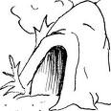
English working paper
Name:
.......................
Module: 4
Lesson:1
Classroom:
........................
Activity:
.......................
Complete the spelling.
Oc _an
P_nd
C _nyon
P _ar

Complete:

The train __________at 11:45. (to leave(
We __________dinner at a nice restaurant on Saturday. (to have(
It __________ in the mountains tomorrow evening. (to snow(
On Sunday at 8 o'clock I _________my friend. (to meet(
5-They __________to London on Friday evening. (to fly(





English working paper
Name:
.......................
Module: 4
Lesson:2
Classroom:
........................
Activity:
.......................
Choose:
Where he ( stay- will stay) if he goes to New York?
If she ( doesn’t stay- didn’t stay) up too late last night, she ( won't be- wouldn’t be) tired now.
I’ll do my homework if this program
( finish- finishes).
4- If you heat water, it (boil – boils)

Rewrite these sentences:
1- Peter is overweight. He eats too much chips. ( If)
_____________________________________
2- He didn't ask us to help, so we didn't. ( If)
_____________________________________
3- I left early so I didn’t know the ending. (If)
_____________________________________



English working paper
Name:
.......................
Module: 4
Lesson:3
Classroom:
........................
Activity:
.......................
Complete the spelling:
1- edu__tional

2- rela__ing

3- cha__enges

Put the words a bove in sentences:

_____________________________________________________________
_____________________________________________________________
_____________________________________________________________




English working paper
Name:
.......................
Module: 4
Lesson: 4
Classroom:
........................
Activity:
.......................
Complete:
They did know the _________of the earthquake. (locate)

The earthquake caused a great ________.
(destroy)

________made a lot of experiments. (science)
They made a good________for the party.
(prepare)

Choose the correct answer:
1 . 'Look outside. ______sky is getting very dark.' `I hope there isn't going to be a storm.'
a. Ab. Thec. θd. Some
2. I'd like to invite him to _______dinner next week, if that's OK with
a. ab. thec. θd. an
3. 'I'm going out for a walk. Have you seen my shoes?' 'Yes, they're on floor in ______kitchen.'
a. ab. thec. θd. an

English working paper
Name:
.......................
Module: 4
Lesson:5
Classroom:
........................
Activity:
.......................

Match:
Dependent make something better

Improve the amount of rain that falls in an area

Rainfall needing somebody

My sister prefers to buy _________gifts that are
useful in someway.

All types of pollution ___________the environment.

The scientists search for a new _________for water.

Complete with (practical - ruin- source)

English working paper
Name:
.......................
Module: 5
Lesson:1
Classroom:
........................
Activity:
.......................
Complete with the past perfect:

1.When I arrived at the cinema, the film ____________________ (start).
2. She ____________________ (live) in China before she went to Thailand.
3. After they ____________________ (eat) the shellfish, they began to feel sick.
4. If you ____________________ (listen) to me, you would have got the job.
Complete with the past perfect progressive:

We (sleep) ___________for 12 hours when he woke us up.
They (wait) ___________at the station for 90 minutes when the train finally arrived.
We (look for) __________her ring for two hours and then we found it in the bathroom.
I (not / walk) __________for a long time, when it suddenly began to rain.




English working paper
Name:
.......................
Module: 5
Lesson:2
Classroom:
........................
Activity:
.......................
Complete:
1) John: "Mandy is at home."
John said that _______________________

2) Max: "Frank often reads a book."
Max told me that ____________________

3) Susan: "I'm watching TV."
Susan said to me that _________________
Fill in the space

1- 'I can't drive.' He said _______drive.

You look nice.' He told me that I _______nice.2

3- "she will go out." she told me that she _____ go out.

English working paper
Name:
.......................
Module: 5
Lesson:3
Classroom:
........................
Activity:
.......................
Write a description of a famous landmark in your country.

__________________________________________________________________________________________________________________________________________________________________________________________________________________________________________________________________________________________________________________________________________________________________________________________________________________________________________________________________________________________________________________________________________________________________________________________________________________________________________________________________________________________________________________________________________________________________________________________________________________________________________________________________________________________________________________________________________________________________________________


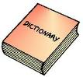

English working paper
Name:
.......................
Module: 5
Lesson:4
Classroom:
........................
Activity:
.......................
Choose:

1- John asked me _____________in English.
A. what does this word mean
B. what did that word mean
C. what that word mean
D. what that word meant
2- She said she ____________collect it for me after work.
A. would B. did C. must D. had

Complete:
1- Christopher: "Do you want to dance?"
Christopher asked me _______________________

2- Where is my umbrella?" she asked.
She asked _____________________________

3- "Take the children to the zoo.” Dad to mum
Dad told mum ____________________________
English working paper
Name:
.......................
Module: 3
Lesson:6
Classroom:
........................
Activity:
.......................
English working paper
Name:
.......................
Module: 5
Lesson: 5
Classroom:
........................
Activity:
.......................
Write a story about something happened to you.

_____________________________________________________________________________________________________________________________________________________________________________________________________________________________________________________________________________________________________________________________________________________________________________________________________________________________________________________________________________________________________________________________________________________




Write the past simple form.
English working paper
Name:
.......................
Module: 6
Lesson: 1
Classroom:
........................
Activity:
.......................
Fly

Land

Eat

Study

______

________
______

______
Write these sentences in passive:
Somebody has taken my briefcase.
____________________________________
The teacher returned our written work
____________________________________
She had finished her report by noon.
____________________________________

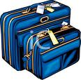


English working paper
Name:
.......................
Module: 6
Lesson: 2
Classroom:
........................
Activity:
.......................
Match:
forecast

tour

weather

Package

Choose the correct answer:

1. Mai worked hard, ______ she passed her exam .
a. so b. although c. because d. though
2. _____ she was very tired, she helped her brother with his homework .
a. Because b. whether c. Although c. so
3. It’s raining hard , _____ we can’t go to the beach .
a. or b. but c. so d. though


English working paper
Name:
.......................
Module: 6
Lesson: 3
Classroom:
........................
Activity:
.......................
Writing:
Write a paragraph expressing your opinion in camping.

____________________________________________________________________________________________________________________________________________________________________________________________________________________________________________________________________________________________________________________________________________________________________________________________________________________________________________________________________________________________________________________________________________________________________________________________________________________________________________________________________________________________________________________________________________________________________________________________________________________________________________________________________________________________________________________________________________________________________________________________________________________________________________________________


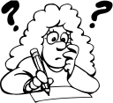
English working paper
Name:
.......................
Module:6
Lesson:4
Classroom:
........................
Activity:
.......................
Put in passive::

Tom was writing two poems.
_________________________________________
Marry is cutting the cakes with a sharp knife.
_________________________________________
They think he is ill.
_________________________________________
Write

Add Suffixes:

Report ___________
Art ___________
Electricity ___________
Reception ___________

English working paper
Name:
.......................
Module: 6
Lesson: 5
Classroom:
........................
Activity:
.......................
Rest_ictions

Econo_ical

Fi_stly

Match:
Such as what is more

Moreover for example

To begin with in the first place

Complete:

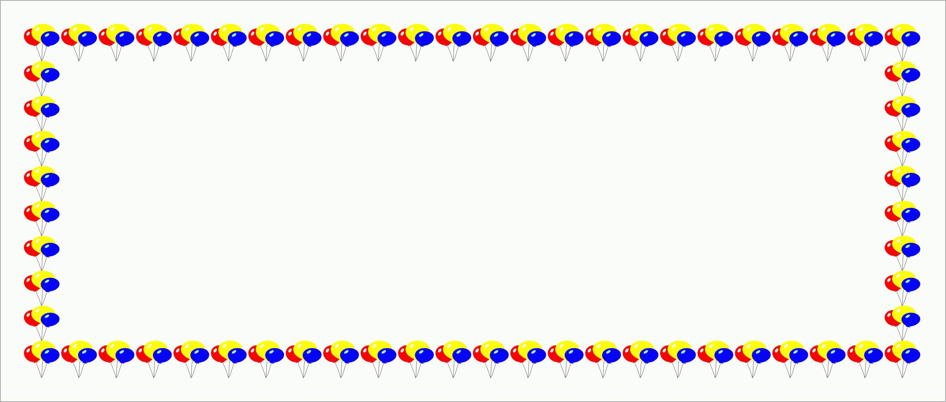


English working paper
Name:
.......................
Module: 7
Lesson: 1
Classroom:
........................
Activity:
.......................
Complete
_________(read) is my favourite hobby.

He stopped _________(run) when he saw me

My father makes me ________(wash) his car

Complete:

1- He demanded ______________ (speak) to the manager.
2- I offered ______________ (help).
3- Finally I managed ______________ (finish) the work.
4- I can ______________ (work) hard.

English working paper
Name:
.......................
Module: 7
Lesson:2
Classroom:
........................
Activity:
.......................
Complete with the causative form:

1. The mechanic changed the oil in my car.
_______________________________________________
2. The hairdresser cut my hair in a completely different style.
_______________________________________________
3. A decorator has repainted our house.

1- trouser blouse facial
2- earrings necklace dress
3- sandals slippers chain

Cross out the odd word:


English working paper
Name:
.......................
Module: 1
Lesson:6
Classroom:
........................
Activity:
.......................
English working paper
Name:
.......................
Module: 7
Lesson:3
Classroom:
........................
Activity:
.......................

Write a letter to the editor of your school telling him your opinion on OLPC project

______________________________________________________________________________________________________________________________________________________________________________________________________________________________________________________________________________________________________________________________________________________________________________________________________________________________________________________________________________________________________________________________________________________-
English working paper
Name:
.......................
Module: 7
Lesson: 4
Classroom:
........................
Activity:
.......................
Choose the correct answer:

Erica must ___ gone out. I can't see her.
have has could
2- He looks tired. He might have ___ awake all night.
Could been has
3- I think James must have ___ all the milk. There's none left.
drunk drank drinking

Complete:

My mother __________her promise and made the cake.
She was nervous and __________her temper.
The company _____________ a meeting every week.
He got up late and ____________his plane.


English working paper
Name:
.......................
Module: 7
Lesson:5
Classroom:
........................
Activity:
.......................
Writing:

You read an announcement about an art course . Write a letter to ask for more information to join it.
___________________________________________________________________________________________________________________________________________________________________________________________________________________________________________________________________________________________________________________________________________________________________________________________________________________________________________________________________________________________________________________________________________________________

