3 Grammar
Exercise 1: Ask and answer about flights, times, arrivals, and destinations.

A: What time is flight 720 arriving? A: What time is Flight 239 leaving?
B: It’s arriving at _____________. B: It’s leaving at ten o’clock.

A: Where is it coming from? A: What gate is it going to depart from?
B: It’s coming from ____________. B: It’s going to depart from _________.
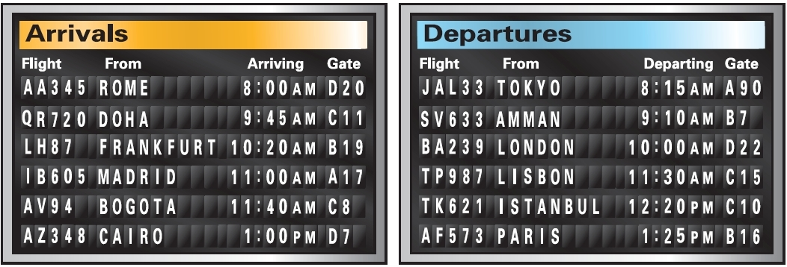

A: ___________________________? A:____________________________?
B: ___________________________? B:____________________________?

A: ___________________________? A:____________________________?
B: ___________________________? B:____________________________?

A: ___________________________? A:____________________________?
B: ___________________________? B:____________________________?

A: ___________________________? A:____________________________?
B: ___________________________? B:____________________________?

