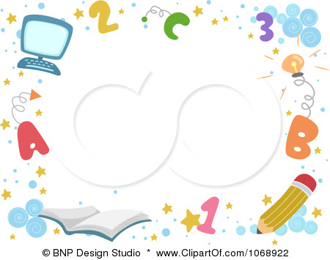
Distribution of the Syllabus For
fourth Grade First Term 1437 – 1438

6th week | 5th week | 4th week | 3rd week | 2nd week | 1st week
22 / 1 – 26 / 1 | 15 / 1 – 19 / 1 | 8/ 1 – 12 / 1 | 1 / 1 – 5 / 1 | 24 / 12 –28 / 12 | 17 / 12 –20/ 12
Unit 3 | Unit 3  Talk time  Rhythms & sounds | Unit 2  Words  Phonics | Unit 2  Talk time  Rhythms & sounds | Unit 1  Words  Phonics | Unit 1  Talk time  Rhythms & sounds
12th week | 11th week | 10th week | 9th week | 8th week | 7th week
12 / 3 – 16/ 3 | 5 / 3 – 9/ 3 | 27/ 2 – 2/ 3 | 20 / 2 – 24 / 2 | 6 / 2 – 10 / 2 | / 1 – 3 / 1229
Unit 5  Words  Phonics | Unit 5  Talk time  Rhythms & sounds | Unit 4  Words  Phonics | Unit 4  Talk time  Rhythms & sounds | Vacation | Evaluation 1
18th week | 17th week | 16th week | 15th week | 14th week | 13th week
24 / 4 – 28 / 4 | 17 / 4 – 21 / 4 | 10 / 4 – 14 / 4 | 3 / 4 –7 /4 | 26 / 3 – 30 / 3 | 19 / 3 – 23 / 3
The Final  Exams | The Final  Exams | Evaluation 2 | Phonic Practice | Work Sheet | Work Sheet
مديرة المدرسة :أ. شريفة علي عسيري

مشرفة المادة : أ .

معلمة المادة : صفية ابراهيم احمد موسى الحارث

التوقيع :

التوقيع :

التوقيع :

