
Year: 1434-1435 AH.
Kingdome of Saudi Arabia Grade:2nd
Ministry of education Term: 2nd
Intermediate School Time: 2 hours
School: Al-Barza School

اسم الطالبة:------------------------------------------ الفصل: / -------- رقم الجلوس: -------------------

Question | الدرجـة رقما | الدرجـة كتابة | المصححة | المراجعة | المدققة
Composition | 5
Reading Comprehension | 5
Grammar | 6
Vocabulary | 5
Orthography (Spilling) | 3
Total | 24

5

Q1: Composition:

Write a paragraph about your pet use the guide words [ my pet - name – colored - eyes – lovely – live - going out – like – feed eat – having time ]
My pet
My pet is a cat . Its name is Fofo . It is black colourd . It has brown eyes .It is very lovely . It lives in a basket. We love going out . It likes playing .I feed Fofo in our garden . It eats fish and meat . I enjoy having time with Fofo.

( 1 )
Q2: Reading Comprehension:
Read the following passage and answer the question :
A-Answer the question :
Ahmed is very happy because his family can go on holiday this year . Last year they couldn’t go anywhere because they were very busy . This year they decide to go to Egypt because there are many interesting things there . His mum can’t go by plane because she is scared of flying . They will have to go by the car .they will visit the pyramids and the Sphinx .They will go to the sea in Alexandria .

5

- 1- why Ahmed is very happy ?
- Because his family can go on holiday this year.
- 2- where do they decide to go this year ?
- they decide to go to Egypt.
- B- complete :
3- His mum can’t go by plane because she is scared of flying .

C : put ( T) or ( F)

4- they will go to the sea in Alexandria . ( T )

6
Q3:Grammar :
A-Choose the correct answer :

1- They are ( going to - will ) destroy that rubbish tomorrow .
2- I can’t stand (waste – wasting ) food.

3-You ( mustn’t - couldn’t ) climb up the tree , it is very dangerous .
4- English is [ speak – spoken – spoke ] all over the world .
5- The news [ are – were – is ] shown on this channel every day .
6- My cousin was [ chosen – chose – choose ] for a scholarship last year.
7- These stamps [ was – is – were ] collected three years ago .
8-The bus is (too-enough) slow, so let's get the metro.

B-Do as shown in brackets :
5- I am going to paint the door tomorrow . (will)
I will go to paint the door tomorrow .
6-Khaldon sells wild animals. ( passive)
Wild animals are sold by Khaldon.

5
Q4:Vocabulary:

A -Match the words with their correct picture:
1-sleepy 2- fan 3-newspaper
4- tyre 5-motorbike 6- stones


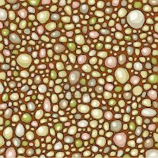
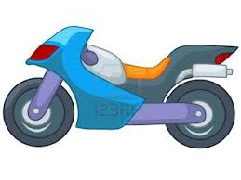
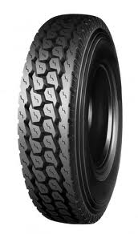
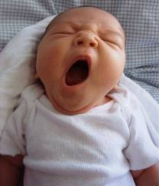
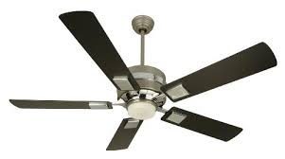

2
1
4
5
6
3

B-Choose the correct word to complete the sentences :
Shopping centre - inventor- trap- breathe

1-The inventor makes new things .
2-This trap Will help us to catch the mouse .
3-Let’s go to the Shopping centre I need a new hat.
4-Humans breathe in oxygen .

Q5:Orthography (Spilling):

3
A-Write the missing litters:
1-scream. 2- flower.
3-ro a d. 4-lock.
5-tour. 6-bush

My best wishes
Mrs.Rania

3--

