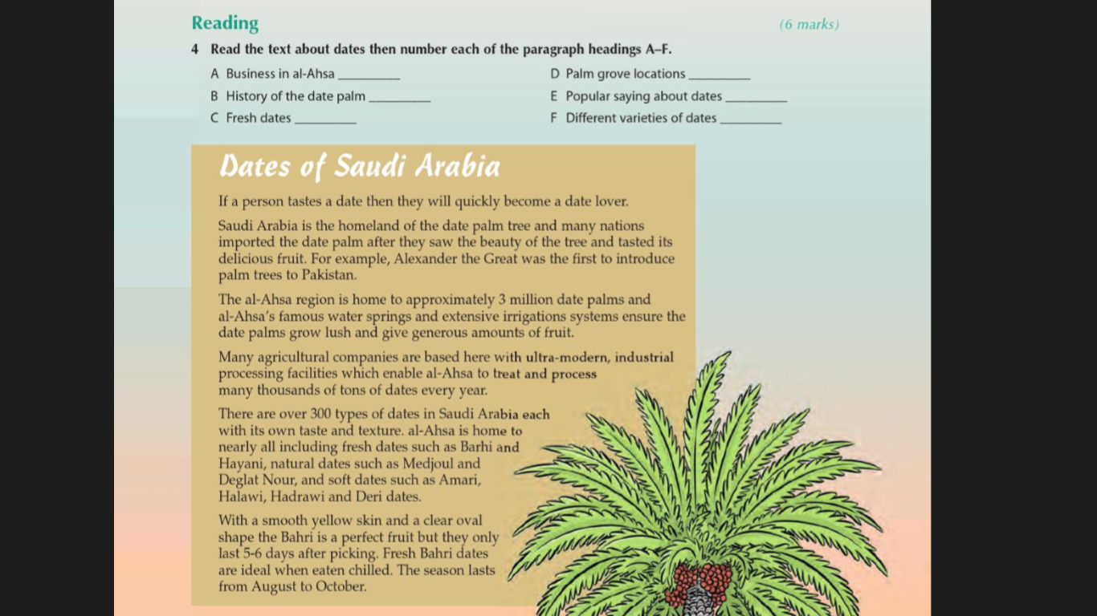
Read the text then answer the questions below :

1-Who is the first person who introduce palm tree in Pakistan ?
………………………………………………………………………………
2-How many type of dates are there in Saudi Arabia ?
…………………………………………………………..
Put true or false:
1-Barhi last only for 5-6 days after picking ( )
2-The season of dates last from August to October ( )
Choose the correct answer :
1-The word type mean ( place – name – kind )
2-One of the most famous dates in Al-Ahsa is ( Barhi – ajouah )

