الفصل الدراسي الثاني / العام الدراسي1437/1436
Test No. ( 1 )
Name: _________________ 6 /___ Class Date: ___/___/1437

رقم المعيار ( 25 )*
Talk about rules using the imperatives
Talk about rules using the imperatives | أ | ب | ج | د
Talk about rules using the imperatives | متقن |  |  | غير متقن

1 – Write the sentences under the correct picture :

( Don’t eat in class - Throw rubbish in the rubbish bin - Don’t take pictures )


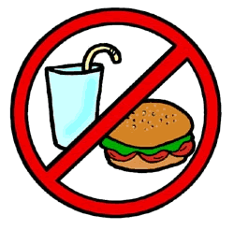

…………………………………………… ……………………………………………… ……………………………………………………………

2 – Fill in the blanks :
( Turn off - Be quiet - Don’t touch )

1 - …………………………… in the hospital .

2 - ……………………………… your mobile phone in the mosque .

رقم المعيار ( 27 ) *
Identify places in a town using the past simple of the verb to be .
 | أ | ب | ج | د
 | متقن |  |  | غير متقن

Fill in the blanks with ( was - were ) :

1 – In the past , there …………………… no shopping centers .

2 – In 1890 , Jeddah ……………………………a small fishing town .

3 – There ……………………… many fishing boats

4 – There ………………………… one big mosque .

5 – In the past, there ………………………… camels .

رقم المعيار ( 28 ) *
Talk about the different times of the day (in the afternoon – in the evening ) .
 | أ | ب | ج | د
 | متقن |  |  | غير متقن
A – Match :
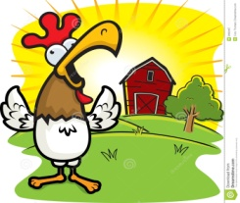
1 – in the evening .

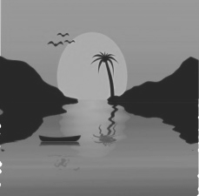

2 - in the morning .

B –Fill in the planks with these phrases :
(in the morning - in the afternoon - in the evening )

1 – I go to bed early at 10 o’clock ……………………………………………………………

2 – I finish school at 2 o’clock …………………………………………………………………

3 – I have breakfast ……………………………………………………………………………………

رقم المعيار ( 36 ) *
Follow a simple text while listening to the audio recording .
 | أ | ب | ج | د
 | متقن |  |  | غير متقن

Listen and fill in the blanks with these words :

( between - unique - climate - island - desert )

Australia Australia is an ………………………………… continent located in the Southern Hemisphere. It lies

…………………………………… the Pacific and Indian oceans and has a land area of over seven million square

kilometers. The ………………………………… in Australia ranges from tropical in the far north to

temperate in the south. Approximately one third of Australia is (4)…………………………………Because it is

a geographically isolated country, Australia has many animals that are ……………………………… Some of

these are the kangaroos, koalas, emus, dingoes and platypuses.

Good Luck ……
Your teacher :

