2-Possessive pronouns
Possessive pronouns | Possessive adjective | Pronouns
mine  His  Hers  -  Theirs  Ours  yours | My  His  Her  Its  Their  Our  your | I  He  She  It  They  We  you

3- There is \ There are

Singular plurals
there is + noun there are + nouns

4-Articals ( a – an – the )

a ( consonant letter )
an ( vowel letters a-u-i-e-o )
the ( noun that found in the previous sentence)

Exercises
*choose:
1-She is ( write – writing – wrote ) a litter now .

2-Whose car is this ?It's ( my – mine) .

3- (There is – There are) a bookshop in the mall.

4-the lamp is( between – in - under ) the sofa and the armchair.
5-This is ( Sami's – Samis` ) car .

6- I have ( a – an - the ) new jacket .

7- ( Whose – who's ) that ? He is Ali.

8- The sofa ( in – opposite – behind ) the fireplace.

*DO as shown between brackets:

1- They ( am) playing football tomorrow . ( correct)
………………………………………………………………………………

2- There is water in the fridge. ( negative )
……………………………………………………………………………………………

3-They are her sisters and this mother is…………. ( add possessive pronoun )

*Vocabulary:

-spilling:

- I have one single bal_ony in my flat and next to the muse_m.

- My co_sin's flat near to the stad_um .

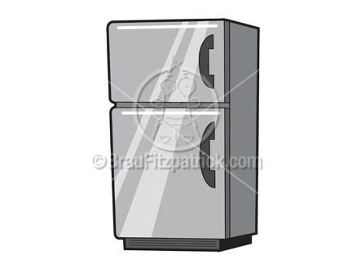


-Match:
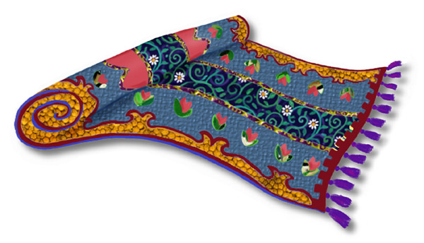

1- curtain 2- fridge 3- rug 4-wardrob

- What's the weather?

cloudy - sunny - foggy - snowy
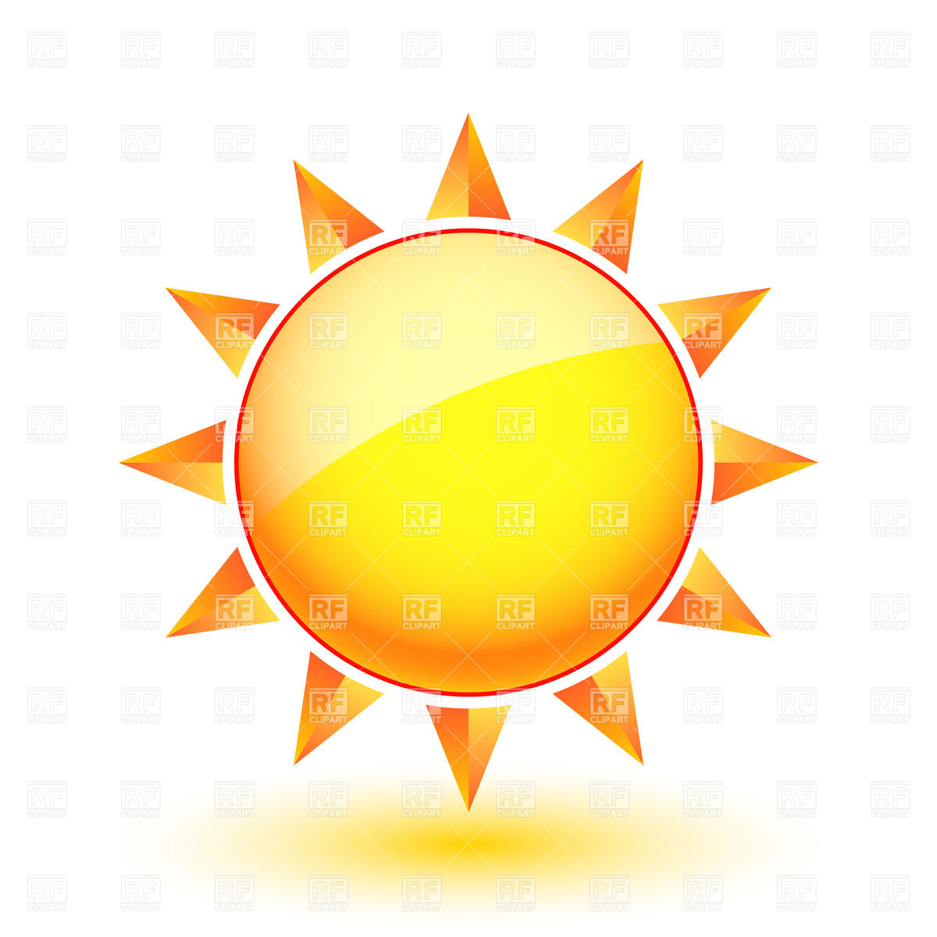




........................ ..................... .................... .............

T.Lammes Al-Omair

