3 Grammar
Exercise 1: : Complete with ( This – That – These – Those ) :
- _________ is a book.

- _________ are pens.
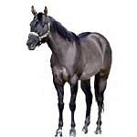
- _________ are apples.
- _________ is a horse
============================================================================
Exercise 2: Complete with (a - an):
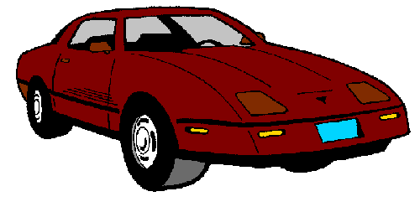
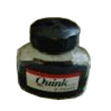
___desk ___egg ___car ___ink

============================================================================
Exercise 3: Work with a partner. Ask and answer. Use this/that or these/those.

A: What are those? A:__________________ A:__________________
B: They’re keys. B:__________________ B:__________________

A:__________________ A:__________________ A:__________________ B:__________________ B:__________________ B:__________________

