1- Comprehension
Read the passage then answer the questions below :
Stonehenge ia a famous circle of stones in southern England near the city of Salisbury.
Archaeologists believe that early Britons built Stonehenge about 4,000 years ago.
These builders didn't have modern tools, but they built this huge monument of stones.
The largest stones weigh about 50 tonnes. Some stones are more than 7 metres high.
People from all over the world visit this monument and ask the same questions. How did they build Stonehenge and why? We may never know the answer.
A - Answer these questions:-
1- How old is Stonehenge ?
.....................................................................................................................................................
2- What questions do people ask about Stonehenge?
..............................................................................................................................................................
B - Choose the correct answer:
1- Stonehenge ia a famous circle of stones in southern ( France - England).
2- The largest stones weigh about ( 50 - 90 ) tonnes.

C - Tick ( √ ) or ( X ):-
1- The builders didn't have modern tools, but they built this huge monument of stones. ( )
2- Some stones are more than 10 metres high. ( )
*****************************************
2-Grammar:
A - Do as shown between brackets :
1- may / rain / it .
................................................................................................
( rearrange the sentence )
2- Who's the girl? She's taking a photo.
.....................................................................................................................................
( Make one sentence )
B - Choose the right answer:
1- Fahad enjoyed the trip to Stonehenge.
a- So did Claudio. b- Neither did Claudio.
2- Reema likes ice-cream.
a- So do I. b- Neither do I.
3- Omar doesn't like coffee.
a- So does Fred. b- Neither does Fred.
4- Lucy and Elena go to school.
a- So do we. b- Neither do we.
5- Ibrahim isn't an English name.
a- So is Ranya. b- Neither is Ranya.
****************************************************************************3-Vocabulary :
A-Mach the words with the correct pictures :
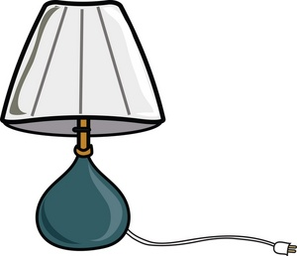
( fitness center - beach - duck - rabbit - river - lamp - basketball - hotel - volleyball )
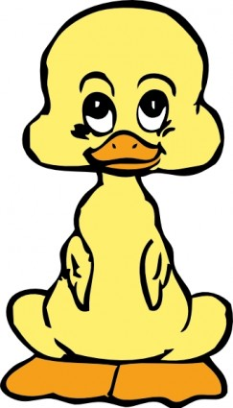
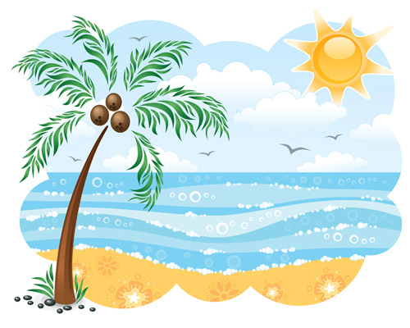

........................................................................................................................................

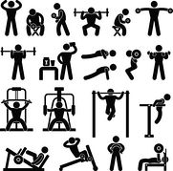
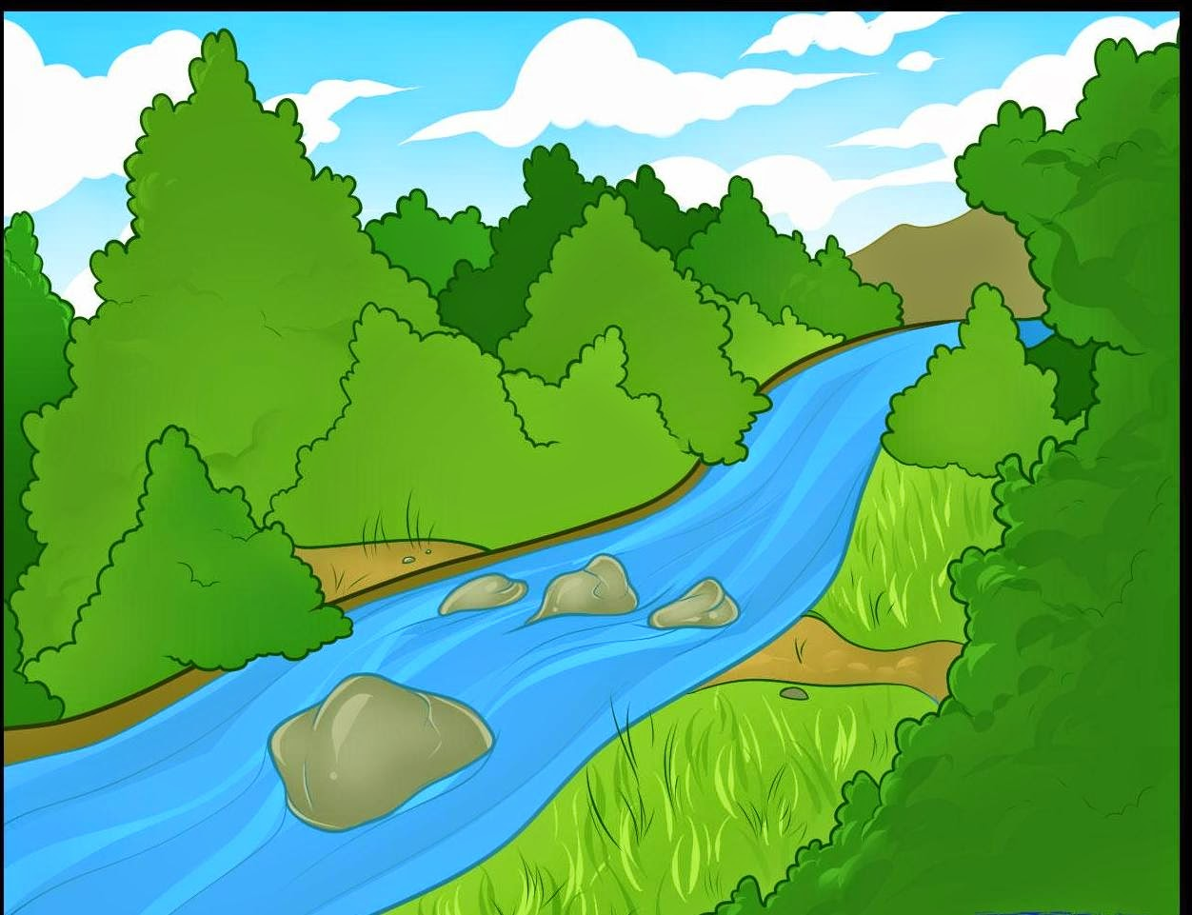

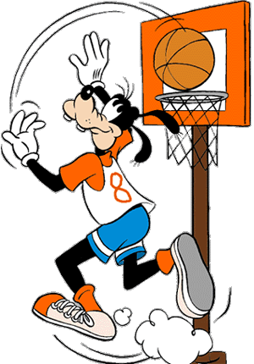
.........................................................................................................
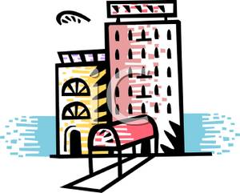
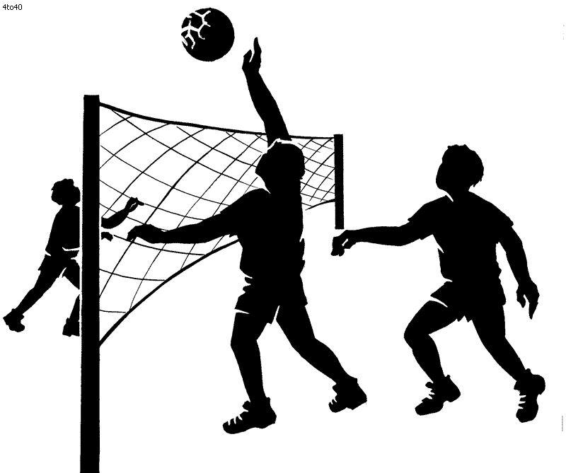

........................................................................................................................................
****************************************************************************
4- Spelling:
A - Choose the correct letters:
1- fe......d ( e – h – m ) 2- ........ole ( z – p – s )
3- Brito....... ( w - a – n ) 4- hu.......e ( b – g - f )
5-s........ack ( g – d – n ) 6- blon....... ( d – k – e )
*********************************************************************

