Kingdom of Saudi Arabia 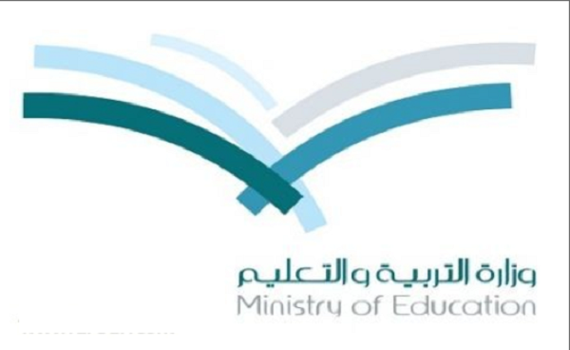 English language

24
Ministry of Education first grade
Alsofairi 1436 / 1437 H
Intermediate School Time : 2 hours

المصحح
المراجع
اسم الطالب:- ....................................................................................الفصل :- .................الجلوس :..................... ..............

Q1: Complete the dialogue by choosing from the words in the box :

4

khalid: Hi, I'm khalid. ............................ your name?
ahmed : My ........................ ahmed. It's ..................... to meet you, khalid.
................. are you?
khalid: I'm fine, ................................. How .................... are you?
ahmed : ................ 13. And you?
khalid: I'm ............

thanks
name's
old
What's
12
nice
How
I'm

8
Q2: Choose the correct answer between brackets:
A)
- she [ am - is - are ] a student.


- They're two [ ball - balles - balls ].

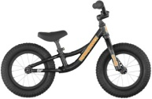
- They're three [ potato - potatoes - potatos ].
- It's ............. bike. [ her - his - their - our ]
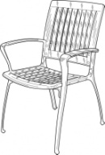
- Is this Nina's book ? ..................., It's Reema's. [ Yes - No - Ok - Hi ]
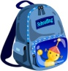
- The bag's [ the right - the left - next to ] the chair.
- She sometimes [ drink - drinks - drinking ] tea in the morning.
- What [ does - doing - do ] you do on Thursday?

B) Look at the words and add – ing :

2
cook ............... write .................. eat .............. take ................

Q3: Write the correct word under each picture :

5

windy - plate - chicken - spoon - bread - rice - fork - knife - tea - raining

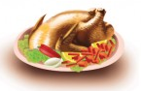
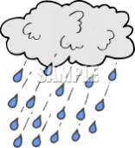
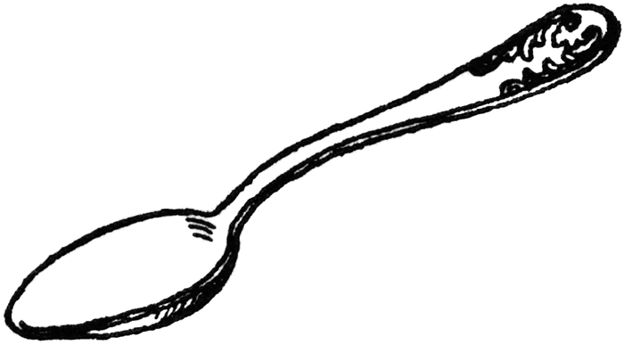
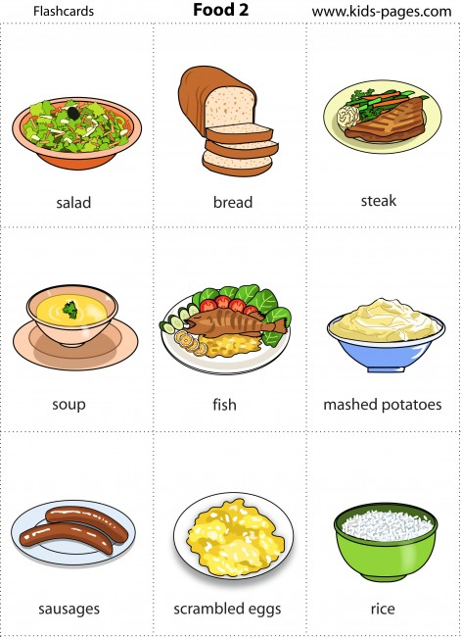
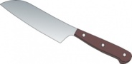

a)……………… b)………………. C)………………… d)…………… e)……………….
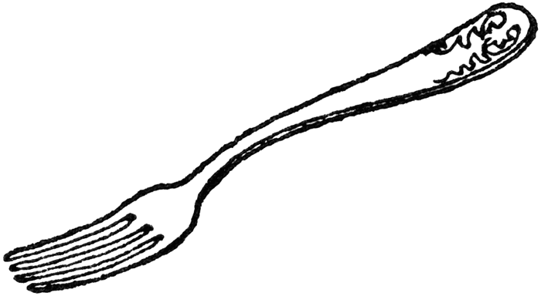


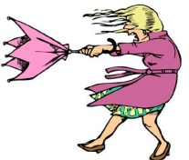

f)………………. g)………………. H)………………... i)……………… j)……………….

2
Q4: Count and write the numbers :
A)



1- 2-

…………………….. ……………………

B) complete the schedule by the correct letter :

3
R | ....
.... | w
Q | ....
.... | n
X | ....
.... | t

Good Luck

T. Abdullrahman M Alshammari

