work sheet unit(1+2)

1) Vocabulary:
A- Write the correct word under each picture:

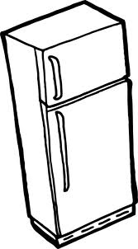


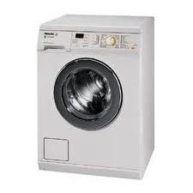
( van – washing machine - maths - fridge – hat )

…………………………………………………………………………………………………………………………………………………
B- Match:
1- play ( ) unfriendly.
2-friendly ( ) information from the net.
3- download ( ) lazy.
4- active ( ) tennis table.

2) Grammar:
A) Choose:
1- Sara always gets up ( at – in - on ) 7:00 a.m.
2-They ( goes – go – went ) to their school every day.
3- Asma is ( reading – read ) a short story now.
4- Ahmed would like ( to go – go ) out for dinner tonight.
5- Maha hates ( read – reading ) newspapers.

B-Do as shown between brackets:
1-She ( clean ) her room every day. (Correct the verb between brackets)
………………………………………………………………………………………………………………………
2- play / on weekdays / I / football / often / don't /. ( Re-arrange )
…………………………………………………………………………………………………………………………………………………

3) Spelling:
1) Ar… 2) i...on
3) be…t 4) c…oker
5) g…m 5) hoo…er
*************************
Best Wishes ☺

