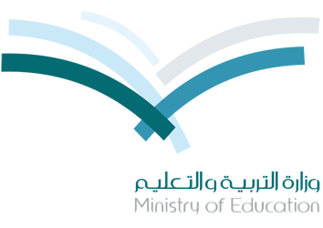
المملكة العربية السعودية
وزارة التربية والتعليم
مدرسة ***** المتوسطة

Kingdom Of Saudi Arabia
Ministry Of Education
******* Intermediate school

EXAM ( 1 )

Name : ………………………………………………………………………………………………………………………………………
Grade : 1\ ………………

الاسم :
الصف :

Q 1: complete with ( a ) , ( an ) , ( some ) :
- Let's buy ……………………… tomatoes and ……………………… chicken .
- I want ……………………… Apple,
but I think there are ……………………… Apples on the kitchen table.

Q 2: complete with ( How much ) , ( How many ) :

- ………………………………… water do you drink a day ?
- ………………………………… cups of coffee does Julia drink every day ?

Q 3: circle the correct words :
- Would you like a nice hot ………………… Of tea . ( cup / can )
- I am ………………… I need some water . ( hungry / thirsty )

Q 4: Look at the pictures and name the items :
- a slice of bread
- a bottle of water

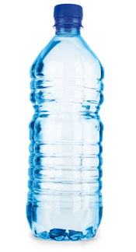
.................................................

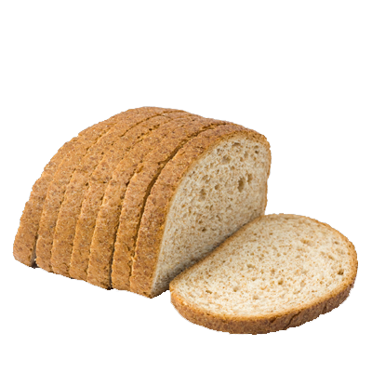
…………………. Is a pencil .
…………………. Is a computer .
.................................................

Good Luck !
Teacher of English Language Mr. *******

