
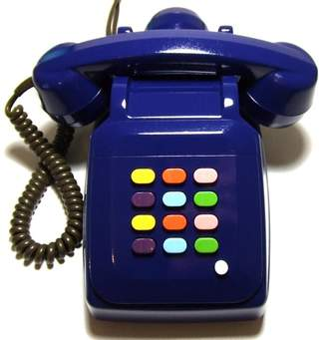
Work sheet \ speaking 2
Arrange the advantages of both kinds in the table :
No need to be recharged – more reliable - portable – economical and convenient
- sending text messages – access the internet -
MOBILE PHONE |  | LANDLINE PHONE
Cheaper -
-More advanced
Useful -
-Come in handy when you out
Find the mistake and correct it , choose the correction form the box:
1- Mobile phone is more outdated than the landline ( )
2- landline phone is more expensive than mobile phone . ( )
3- mobile phone is posing a health hazard as headache and cancer ( )
Work sheet \ speaking 2
Arrange the advantages of both kinds in the table :
No need to be recharged – more reliable - portable –
economical and convenient - sending text messages – access the internet -
MOBILE PHONE |  | LANDLINE PHONE
Cheaper -
-More advanced
Useful -
-Come in handy when you out
Find the mistake and correct it , choose the correction form the box:
1- Mobile phone is more outdated than the landline ( )
2- landline phone is more expensive than mobile phone . ( )
3- mobile phone is posing a health hazard as headache and cancer ( )

