Kingdom of Saudi Arabia English Language

Ministry of Education 1st Grade /Inter.
ministry for Girl's Education Second Term 1434/1435
Al-Barza School Final Exam-first round.

Name:…………………………………………. Time: 2 hours

Question | الدرجـة رقما | الدرجـة كتابة | المصححة | المراجعة | المدققة
Composition | 5
Reading Comprehension | 5
Grammar | 6
Vocabulary | 5
Orthography (Spilling) | 3
Total | 24

Q1:

5
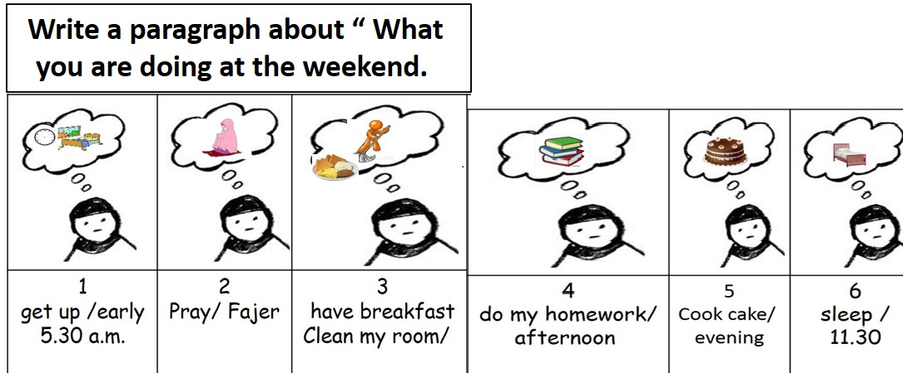
My Weekend
I am getting up early at 5:30 in the morning then I pray Fajer prayer. I am having breakfast and cleaning my room. In the afternoon I doing my home work. I am doing some cake in the evening. I am sleeping around 11:30

( 1 )

Q2:Comprehension passage:

5
5
Read the passage then answer the questions ;
Wafa is a teacher at small school . She teaches children . She has 21 children in her class ,12 boys and 11 girls .She likes them too much and they like her too . She is very patient and helps them a lot . She is a very good teacher .
- Questions :
- Is Wafa work a teacher ?
Yse, she is.
2- How many girls are there in Wafa 's class ?
There are 11 girls.
- Choose :
1- She is very [ bad - good - big ] teacher.
2- Wafa works at small [ house – mosque – school ] .
C) Put (✓) or (✗) and correct:
3- She has 100 children in her class .( x )
4- She is very patient.( ✓ )

6
Q3:Grammar: 5
A-Choose the right word :
1-He is ( play – playing –played –plays ) basketball .
2- we must ( clean – cleaning – cleaned – cleans ) the house .
3- I ( eat – eating – ate – eats ) cake yesterday ,
4- Cheetah is ( fast –faster than –fasting – fasted ) Camel.
5- The Elephant is ( big – bigger – the biggest – bigs ) animal,
6- they will ( travel – travelled –travelling – travels ) next week .

( 2 )

B -Do as shown between brackets :
- He is sleeping now .
He isn't sleeping now. ( Change into Negative using not )
2 - are - stories - They - reading - .
They are reading stories. ( Re-arrange the sentence )

3- Will she study English ? ( Write short answer with Yes )
Yes, she will.

Vocabulary

A) - Circle the odd word :

5
1- Pilot – Doctor– house –
3- House –cat- Castle – 5
4- bus – camel – Cats –
B) - Match [ A] with [ B ] : :-
A | B
- Plane | [ 4 ] station .
- Ship | [ 3 ] stop .
- Bus | [ 2 ] port .
- Train | [ 1 ] airport .

C) : Match words with photos : ( igloo – camel –space ship –tower )




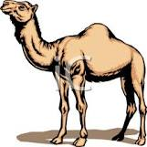

1- camel | 2- tower | 3- igloo | 4- space ship

( 3 )

Q5:Orthography (Spilling)

A-Choose the correct spelling:

3

 |  |  |  | 
1-nayri | 1-ylocud | 1-cold | 1-bike | 1-football | 1-wnosy
2-rainy | 2-cloudy | 2-dolc | 2-keib | 2-fotoblal | 2-snowy

My best wishes
Mrs.Rania

( 4 )

