
__48_
48

Kingdom of Saudi Arabia
Ministry of Education
Tabuk Educational Zone
The 1st Intermediate school

The Final Exam
Second term
1435-1436 H
Third grade
Time:2 hours
Pages NO.:4

اختبار كامل المنهج
for 3rd Grade intermediate (1435 / 36 A.H.)
… Seat No: …………........class:............................................................... : s nameۥStudent

(( اللهم لا سهل إلا ما جعلته سهلاً وأنت تجعل الحزن إذا شئت سهلاً)).

Checked by | Reviewed by | Corrected by | Marks by  writing | Marks by  NO. | Question’s No.
 |  |  |  |  | Question 1
 |  |  |  |  | Question 2
 |  |  |  |  | Question 3
 |  |  |  |  | Question 4
 |  |  |  |  | Question 5
____48___  48 |  |  |  |  | TOTAL

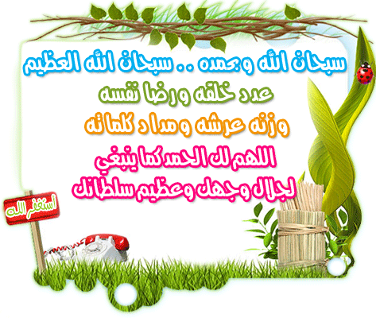

( 1 )

10

10
I- Composition
Q1: Write an e-mail to your friend to apologize that you're busy:
[asked – math homework – sorry - because ]
...........................................................................................................................
Any suitable answer for the student .
2marks for ideas - 1 for structure - 2 for writing techniques
.................................................................................................................................................

********************************************************************************************
10

10
II- Comprehension
Q2: Read the following passage then, answer the questions:
Mrs. Sara often spends too much money on clothes. She does not need new clothes, but she loves buying them . Yesterday she saw a beautiful coat in a shop window . She went in and put it on . It was just the right size, but it was very expensive . Mrs. Sara did not have enough money ,but she took the coat home and showed it to her husband . He liked it very much , but he did not like the price. His wife gave him a bill for 2000 RS.
A- Answer the following questions:
1- Does Mrs. Sara often spend money on clothes?
Yes, she does. (2 m)
2- What did she see in a shop window yesterday?
Yesterday she saw a beautiful coat in a shop window . (2 m)
3- Was it too small ,too large ,or just the right size?
It was just the right size. (2 m)
B- Choose the correct words:
1- Her husband did not like
a- the color of the coat b – the price of the coat. (1 m)
2- The coat was very
a- expensive b- very cheap. (1 m)
C- Put ( T  ) or ( F  ) :
1- Mrs. Sara left the coat in the shop ( F  ) (1 m)
2- Mrs. Sara does not need new clothes , but she loves buying them(T  ) (1 m)

************************************************************
( 2)

III- Grammar
12

12
Q3: A- Choose the correct answers :
1- She ( am - is - are ) speaking to another student . (1 m)
2- Omar really hates ( getting - get – got ) angry . (1 m)
3- The country ( has - have - had ) changed . (1 m)
4- Fatimah ( watches - watching - watched ) TV in the evening. (1 m)
5- Speak politely to a stranger by ( use - used - using ) sir or madam. (1 m)
6- Nasser is the boy ( who - where - which ) became the first on his class . (1 m)

B - Do as shown between brackets :

1- He / drinking tea /prefers /to coffee. ( rearrange)
He prefers drinking tea to coffee. (2 m)
2- a)- become become. b)- do done . (2 m)
( write the past participle of the verbs )

3- Could you switch off the air-conditioner ?
OK. (2 m)
( Accept the request )
******************************************************************************
10

10
IV- Vocabulary

Q4: A- complete the table:

Verb | sport | person
box | boxing. (1 m) | boxer. (1 m)

B- Put the right words under the right pictures:
diver - around – doctor – over - teacher




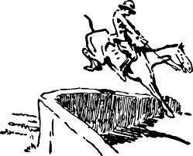
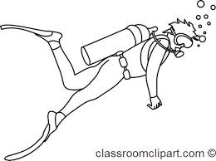

around(1 m) doctor(1 m) over(1 m) diver(1 m)
( 3 )

C- Write the correct words :
expression – stranger – madam - mistake - grammar

1- the look on a face expression. (1 m)
2- if something is not correct , it is a mistake. (1 m)
3- we do not know this person stranger. (1 m)
4- a formal way to speak to a woman madam. (1 m)

***********************************************************************************************

V- Spelling

6

6

Q5: A- Write the missing litters :

1- leathe………… [ s – r- o ] (½ m) 2- ……… etal [ m – g – e ] (½ m)
3- ………lastic [ i – j- p ] (½ m) 4- stee ………[ o – l – x ] (½ m)

 | 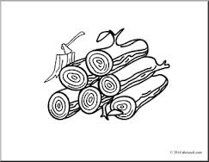 | 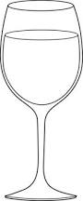 | 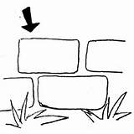
bobir  paper(1 m) | wood(1 m)  weid | jlac  glass(1 m) | brick(1 m)  prook
B- Choose the right spelling :

***********************************************************************************************
The End.
With our best wishes
Your teachers : .....................

( 4 )

