Complete the sentences with the correct words.
Match the sentences with the pictures.
Kate .......................................... tennis every Friday. (play)
The baby ........................................... at the moment. (sleep)
My grandparent .......................................... television now. (watch)
My brother and I ................................ karate every Monday. (do)
My favourite season ........................................... spring. (be)
Susan ........................................... coffee. (like)
Eric ........................................... his homework at the moment. (do)
My grandpa ........................................... five cups of tea every day. (drink)
Jane ........................................... a picture at the moment. (paint)
Peter ........................................... in the garden now. (work)
Mandy ........................................... a bike at the moment. (ride)
I always ........................................... a sandwich for lunch. (have)


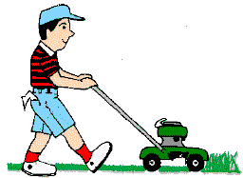

a
b
c
d
g
h
i
j
l
k
f
e
KEY
- plays
g
- is sleeping
j
- are watching
i
- do
h
- is
d
- likes
b
- does
l
- drinks
c
- is painting
a
- is working
e
- is riding
k
- have
f
This worksheet is dedicated to my beloved son Tom, who died in2014.
http://busyteacher.org/19543-my-son-tom.html

