**الاسم : الفصل :**

**A**

**1* ) Choose the correct meaning :**

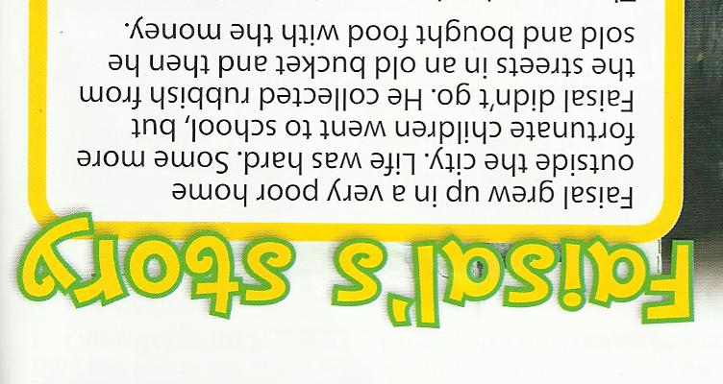

ANSWER

1- Faisal grew up in a **( poor – rich )** home.

2-He collected **( food – rubbish )** from the streets.

**2* Choose the correct answer :**

1- We **( study – studied )** Math last week.

2-**( Did - Do - Does )** you study Math yesterday?

3-He **( watching - watches - watched )** TV yesterday.

4-They **( was - were- is )** happy last night.

5- I **( bought – buy – buying )** a new book yesterday .

**3* Choose the correct word for these pictures :**

**Fridge – oven – balcony - rug**

………………. ……………….. ………………….

