**The Kingdom of Saudi Arabia**

**Ministry Of Education.**

**Name:……………. Class:……………**

**الصف الثاني المتوسط**

**English Written Mid Term Exam 1433-1434 H- 2nd Term -**

**10**

***Q1. Use the following words:***

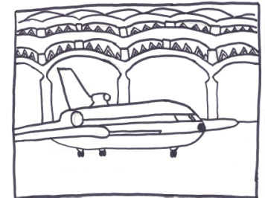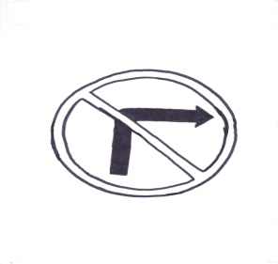

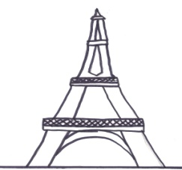

1. airport 2. Eiffel Tower 3. Don't turn right.

Q2:Answer the questions:

a. Are the traffic signs important ?

{ Yes , they are. – No, They are. – They are not .}

b. What is the matter with you?

{ He has a headache. - You have a headache. - I have a headache .}

Q3: Choose ;

1. He is driving ( quick – quickly ) .

2. My report is the { good- better – best} ?

3. Riyadh is the ( crowded – more crowded – most crowded ) .

4. ( Was- Were - Are) Ahmad in Makkah last week ?

5. The school is ( in – over – on ) the right .