**Write the suitable words under each pictures:-:-**

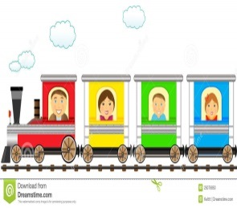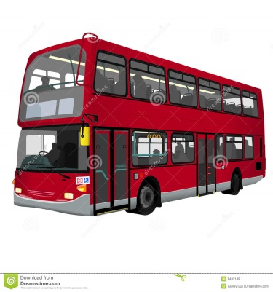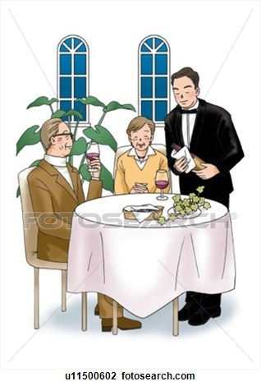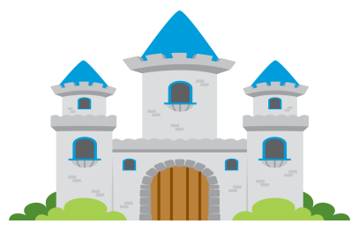



**Give the past tense :-**

go…………………. take…………………… eat…………………… see……………………….

read……………………….. write……………………. forget………………………..

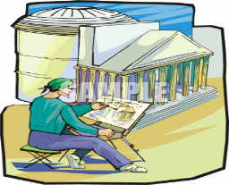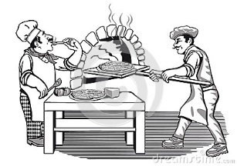**Write the suitable words under each pictures:-**

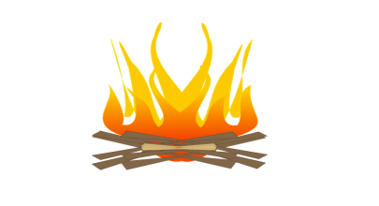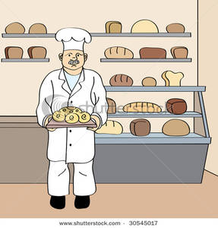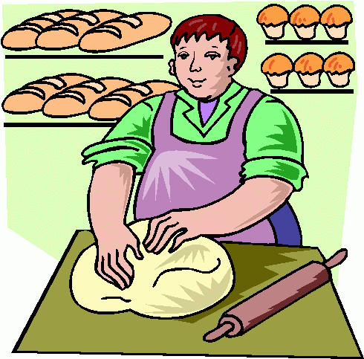

**Choose the correct words**:-

1-I asked ( **all – both** ) housekeeper and the servant about my jacket.

2- ( **All – Both** )children over five have to go to school in England.

3-Jill and Linda are sisters. ( **All – Both** ) of them want to get married next year.

4-I saw two lovely hand-bags in a shop this morning. I bought them( **all – both** )

**Do as shown between brackets:-**

1-It is catching the fire. **( Change the sentence into past tense)**

…………………………………………………………………………………………………………………………………………………….

2- blow……………………………… wake………………………………. **( Give the past tense)**

F:\المناهج المطوره\كل مايخص 2م\exit-md.png**Write the suitable word under the picture:-**

**Choose the correct answers:-**

1-I want my children to behave **(nice – nicely)** to every person that they meet.

2- The girls had to finish their work **( quick – quickly )** because the teacher told them to stop.

3- When he was a child, Tony spoke very **( quite – quietly )** and his friends couldn't understand him.

4- The group found their hotel **( easy – easily )** after they bought the map of the city.

5- I wish that I could explain things **( clear – clearly)** .

**Give the opposite:-**

Came X…………………….. remembered X………………………………….

Learned X…………………….… slept X…………………………….