Date:………………………………….

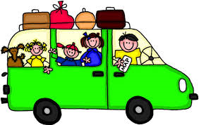

***New words adjectives expressing opinion :***

*1-dinosaur 5-journey*

*2-experiment 6-arrive*

*3-hope 4-invention*

-

*1-amazing 7-interesting*

*2-awful 8-frightening*

*3-brilliant 9-horrible*

*4-cool 10-wonderful*

*5-exciting 11- weird*

*6-fantastic*



*Match:*

*1-Explore ---hiking*

*2-go on ---a trip*

*3- do ---souvenirs*

*4-buy ---a cave*

*5-go ---an experiment*



**Circle the correct words:**

*1-We went to the restaurant { by / on } foot*

*2-A: yesterday at school we did a brilliant { experiment / invention }*

*B : Wow , that's { cool / horrible }*

*3-The sailors were very { crowded / excited } when they reached the coast*

*4- the { trip / voyage } to the museum was interesting*

*5-it's a good thing to keep family { networks / traditions }*

*6-in the past, a bridge { connected / carried } the two countries .*

***Complete the sentences with the adjectives below***

*Dangerous / expensive / fast / crowded / popular*

*1-When something isn't cheap it's …………………..*

*2-When something isn't slow , it's …………………..*

*3-When lots of people like something , it's ………………..*

*4-When there are lots of people in a place , it's………………..*

*5-When something isn't safe, it's ……………………*

Date:………………………………………





***New words parts of the body verb related to accidents***

1-ambulance 6-strange

*2-banana skin 7-suddenly*

*3-exactly 8-pavement*

*4-explain 9-just*

*5-lie*

***1-bleed 5-hit***

***2-break 6-hurt***

***3-crash into 7-slip***

***4-fall down 8-sprain***



***Past progressive الماضي المستمر***

***نستخدم الماضي المستمر لفعل أو حدث حصل في وقت محدد في الماضي 0 مثال على ذلك***

*I was watching TV at seven o'clock yesterday evening كنت أشاهد التلفاز الساعة السابعة مساء الأمس*

*وطريقة تكوين جملة في الزمن الماضي المستمر عبارة عن أولا الضمير يتبعه was , were ثم الفعل ثم ing مثال:*

***\*he was eating *they were eating***

***وعند تكوين سؤال بنعم أو لا في الزمن الماضي البسيط نقوم بعمل الأتي***

|  |  |  |  |
| --- | --- | --- | --- |
| *Ing* | *Verb* | *I , he ,she , it* | *Was* |
| *Ing* | ***Verb*** | ***You , they , we*** | ***Were*** |

***Look at the pictures and write what happened to these people yesterday***

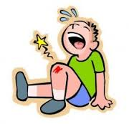 …………………………………………………….

Break

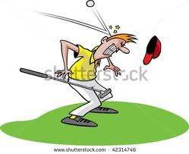 ………………………………………………………………….

Hit

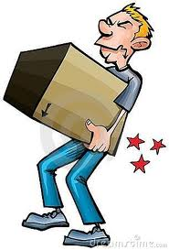 ……………………………………………………….

hurt

***Complete with the past progressive of the verb in brackets:***

***1-I ……………………….. { download } some information from the internet.***

***2-last night Abdullah …………………… …. { not study } for the test. He …………………………….. { play } computer games .***

***3-What ……………… you ……………….. { do } last night?***

***4-We …………………………… { watch }football on TV.***

***5-Rob and Alex …………………………….. { talk } on the phone all afternoon.***

***6-the cat …................................. { not sit } on the sofa***



***Complete the sentence with the words in the box:***

*Slipped / middle / ambulance / crashed / explain / bleeding / accident / jumped*

***1-the was standing in the ………………….. of the room .***

***2-Saleh……………………and fell down the stairs .***

***3-Alex …………………..off a chair and broke his leg.***

***4-They called for an …………………..and it took Hatim to hospital .***

***5-Oh no! your nose is …………………. What Happened?***

***6-Nouf's father had a car ……………………yesterday. He ………………….into a wall.***

***7-Can you ……………………this to me ? I don't understand .***



***New words***

1-brush 8-footprint

*2-Calm 9-frightened*

*3-Campsite 10-hole*

*4-Chase 11- huge*

*5-Cliff 12-organise*

*6-dark 13-scream*

*7-shadow 14-wild*

***نستخدم زمن الماضي المستمر والماضي البسيط في نفس الجملة عندما يكون فعل أو حدث حصل في الماضي ويقطع بفعل آخر حدث في الماضي 0 نستخدم الماضي المستمر للحدث الأطول والماضي البسيط للحدث الأقصر***

***نستخدم While + past progressive : while مع الزمن الماضي المستمر***

***نستخدم : When + past simple نستخدم when مع الزمن الماضي البسيط***

***أمثــــلة : 1-While I was driving , I saw a cat in the street.***

***2-I was sleeping when the telephone rang***

***Choose a or b :***

*1-We…………. a woman scream while we were having dinner.*

***a) were hearing b)heard***

*2-They were following the huge footprints …………..suddenly a wild animal appeared*

***a)While b)When***

*3-The Children…………….football when they broke the window.*

***a)played b)were playing***

*4-While Vicky …………….her room , she found 20$*

***a)Was tidying b)tidied***

*5-Was Lisa eating a sandwich while she …………….the net?*

***a)surfed b) was surfing***

*6-The boys were swimming in the river when their friends ………….*

***a)arrived b) were arriving***

*7-While Paul was reading a book , Alice ……………….*

***a)was cooking b)cooked***

*8-jessica was doing her home work …………… the phone rang*

***a)When b)While***



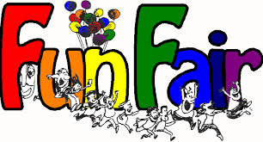

Date:………………………………………….

***New words***

*1-bumper car 7-milkshake*

*2-Candy floss 8-popcorn*

*3-corn on the cob 9-prize*

*4-crisp 10-rides*

*5-doughnut 11-roller coaster*

*6-ferris wheel 12-water slide*

*13 - queue*

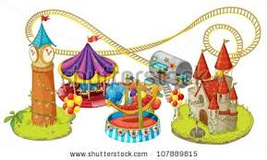



***Some / any / no***

***نستخدم some في الجمل المثبتة ومن أمثلة ذلك:*** ***there are some books on the desk***

***كذلك تستخدم في السؤال عندما نعرض أو نطلب شيء بتهذيب مثال ذلك:***

***Would you like some water?***



***Any نستخدمها أولا في السؤال : Is there any milk on the table ?***

***ثانيا: في الجمل المنفية مثال ذلك: there aren't any books on the table***



***No نستخدمها في الجمل المثبتة لأعطاء المعنى السلبي مثال ذلك:***

***There's no milk in the glass***

***Choose the correct answer***:

*1-Are ……….. bananas left? I want to make a banana cake .*

*a)any b)some c)no*

*2-there ………….people on the water slide .that ride isn't very popular.*

*a)any b)no c)some*

*3-I don't want to do ………….work at the weekend .I want to stay at home and relax .*

*a)no b)some c)any*

*4- I think I saw ………..men outside the house . let's call the police.*

*a)no b)any c)some*

*5-Can I have …………..milk in my tea please?*

*a)no b)any c)some*

*6-the children found …………… kitten in the garden .*

*a)any b)no c)some*



***Look at the picture and complete the text***

*Last weekend my friend Sultan and I went to the ………………………………..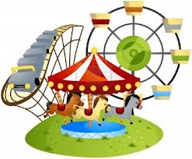. We went on the……………………………. 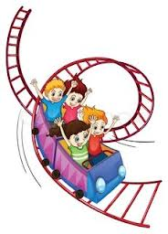 . and the ……………………………..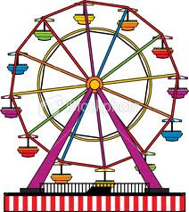 but my favourite was the …………………….……. 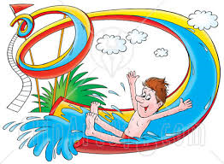. We got all wet ! After that , Sultan wanted to go on the ………………………..……….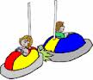but there was a long ……....................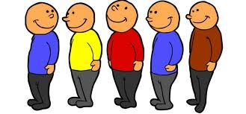so we went to the food stand and had a snack. I had some ………………………..……….Sultan had a……..………………………….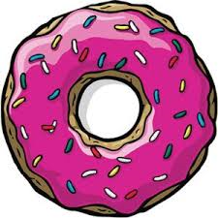and a .…………..………………. 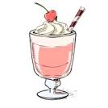.then we went back to the rides .it was great fun !*

…



***1-Attack 8-save***

***2-bite 9-scare***

***3-brave 10-shark***

***4-far 11-wolf***

***5-crazy 12-human***

***6-lose 13-return***

***7-neck 14-few***

Date:……………………………………………

***1-worried***

***2-angry***

***3-shocked***

***4-lonely***

***5-surprised***

***6-embarrassed***

**Answer the following questions:**

***1-How do you feel if you lose a friend?***

***---------------------------------------------------------------------------***

***2- put { T } or { F }***

***My mother is happy about my brother because he didn't answer his phone. { }***

***\*Andy is angry because his brother borrowed his car and crashed into a tree { }***



***Complete the text with the words in the boxes :***

*Attack shocked alone scared saved*

***When I went to Florida last year for my holiday .i had a horrible experience. A man was swimming and suddenly , he shouted " SHARK" . I was ……………………. On the beach and I didn't know what to do. But luckily the shark didn't …………………………. . something ……………………………. The shark away and I jumped into the water and…………………………… the man . he was really ……………………………*** 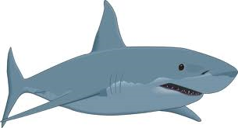

***Circle the correct word:***

***1-Mary was { shocked - lonely } when she heard the bad news.***

***2-Last year , a shark { worried - attacked } my cousin when he was on holiday.***

***3-My uncle is very { brave - angry } he isn't afraid of lion***

***4-I like trying { another - different } types of food.***

***5-My brother is very { angry - embarrassed } with me because I borrowed his laptop without asking him first***

Date:………………………………………………



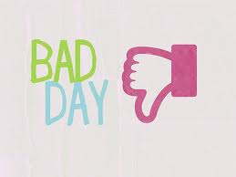

1-get lost

*2-get stuck in a left*

*3-get a flat tyre*

*4-get locked out*

*5-lose one's keys*

*6- miss the* bus

1-adventure

2-fix

3-ladder

4-mention

5-neighbour

6-unfortunately

*Never let a bad day make you feel like you have a bad life*

***Complete the sentences with the words in the box***

***Missed ladder tyre lift locked neighbor***

***1-Matt used a …………………………. To climb up the tree.***

***2-My parents got stuck in the ………………………. Yesterday.***

***3-I ………………………..the bus this morning and I walked to school.***

***4-My next door …………………………….. saw a huge spider in his kitchen yesterday.***

***5-we got …………………..out of our house last night .***

***6-Zayed was late for work today because he has got a flat………………………***



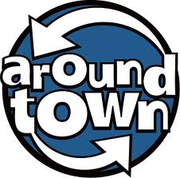

Date: …………………………………………………

1-bring 2-card 3-euro 4-flight 5-medicine 6-shelf 7-stamp

8-ticket 9-travel agent's 10-post office 11-newsagent's 12-market

13-library 14-hairdresser's 15-florist's 16-chemist's

***Can / Could / May / Might***

*نستخدم Can I…….? , Could I ……..? , May I……..? لغرض الطلب مثال على ذلك:*

***Can I get you something to drink?***

*ثانيا : تستخدم لطلب الأذن 0000 مثال على ذلك* ***: May I use the phone?***

*ثالثا: تستخدم Can I ……..? , Could I………? لطلب معروف مثال على ذلك: Can you help me with my home work*

*وللطلب بشكل مهذب ولكن could افضل استخداما بهذه الحالة من can مثال على ذلك*

***Could you give me glass of water***

*\*May , Might , Could تستخدم للتعبير عن الإحتمالية في الضارع أو المستقبل*

*مثال على ذلك : it may / might / could rain today*

*\*might تستخدم للتعبير عن أقل الأحتمالات مثال على ذلك :* ***we might go to the park , but I am not*** *s****ur****e*

صث ةهWe

***.***

**Complete the sentences with the places in the box**

Hairdresser's newsagent's florist's library travel agent's Chemist's post office market

*1-you can buy magazine and news paper at the……………………………….*

*2-you can post a letter or buy stamps at the …………………………………..*

*3-you can borrow books from the………………………………………………*

*4-you can get a haircut at the……………………………………………….…*

*5-you can book a holiday at the …………………………………………….…*

*6-you can get medicine from the ……………………………………………...*

*7-you can buy fruit and vegetables at the………………………………….…*

*8-you can buy flowers at the ………………………………………………..*



*.* 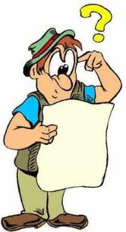

Date:…………………………………………..

*1-bank 2-bus stop 3-catch 4-footbridge 5-map pedestrian crossing 7-petrol station 8-police station 9-robber*

*10-stop sign 11-traffic lights 12-tunnel 13-go straight 14-turn left*

*15- turn righ*t

***Preposition of places***

***In front of / behind / opposite / between / next to***

***Preposition of movement***

***Up / down / into / out of / through / towards / past / from / to / around***

***Circle the correct words:***

*A: Excuse me . where's the chemist's ?*

*B: it's on baker road*  ***{ through / between }*** *a newsagent's and a book shop .*

*A:is it far?*

*B:No , it's about five minutes* ***{ out of / from }*** *here . Go* ***{ down / through }***  *Palm street and turn right*  ***{ to / into }***  *Malcolm Road. Walk {* ***up / towards }*** *this road , go*  ***{ around / past }***  *the supermarket and turn left* ***{ behind / at }***  *the traffic lights. That's Baker Road . the Chemist's is*  ***{ in /on }***  *your left .*  ***{ next / opposite }*** *to a newsagent's*

Date :…………………………………………………



**Types of houses**

*1-block of flats*

*2-bungalow*

*3-caravan*

*4-cottsge*

*5-farm*

*6-houseboat*

*7- tree house*

*1-annoying 7-general*

*2-barbecue 8-kill*

*3-busy 9-nature*

*4-country 10-peaceful*

*5-do gardening 11-noisy*

*6-excitement 12-prefer*

7

***Comparative form صيغة المقارنــــــــــــة***

*تستخدم صيغة المقارنة للمقارنة بين شيئين 0 لابد أن نعرف قبل المقارنه أن هناك صفات قصيرة وصفات طويلة وصفات شاذة*

***بالصفات القصيرة نضيف er للصفة وعند عمل المقارنة يكون ترتيب الجملة هكذا***

*Fast + er + than مثال على the train is faster than car*

***\*بالصفات الطويلة نستخدم more قبل الصفة ثم than مثال على ذلك***

*The house is more expensive than the car*

***\*بالصفات الشاذة تغير كل الصفة مثال على ذلك good better***

*Ahmed is better than Faisal*



***New words words related to space***

*1-Earth 6-planet*

*2-galaxy 7-solar system*

*3-moon 8-star*

*4-outer space 9-sun*

*5-planet 10-universe*

*1-billion 9-minus*

*2-center 10-move*

*3-fit 11-over*

*4-freeze 12-scientist*

*5-heat 13-second*

*6-heavy 14-sunlight*

*7-inside 15-temperature*

*8-light 16-thousand*

***Superlative forms صيغة التفضيل***

*تستخدم صيغة التفضيل للأفضلية بين الجميع 0 لابد أن نعرف قبل المقارنه أن هناك صفات قصيرة وصفات طويلة وصفات شاذة*

***بالصفات القصيرة نضيف the ثم الصفة + est وعند عمل المقارنة يكون ترتيب الجملة هكذا***

*Fast + est the + مثال على the plain is the fastest transport*

***\*بالصفات الطويلة نستخدم the mostقبل الصفة ثم الصفة مثال على ذلك***

*This house is the most expensive one in this city*

***\*بالصفات الشاذة تغير كل الصفة ونضيف قبل الصفة the مثال على ذلكbetter the best***

*Ahmed is the best student in the class*

*Complete the sentence with the correct form of the adjectives in brackets:*

*1-Malik is ...…………. ( tall ) than Saleh ,but Hasan is the ……………….. ( tall ) of the three.*

*2-I didn't have a lot of money on me so I bought the …………….. ( cheap ) T-shirt in the shop*

*3-The National Museum is ………………………….. ( popular ) than the history Museum .*

*4-I think it's the ………………… ( cold ) day of the week today .*

*5-My uncle's car is ………………………….. ( modern ) than my dad's .*

*6-Who's the …………………………….. (famous ) scientist of our century?*



*Date :………………………………………….*

New words

*1-building 7-art gallery 13-stadium*

*2-exhibition 8-bridge 14-tower*

*3-fascinating 9-car park 15-train station*

*4-tourist 10-castel 16- sight*

*5-airport 11-mosque 17-view*

*6-aquarium 12- port 18-capital*

***Circle the correct words***

*1-there are many boats in the { port / car park }*

*2-Be careful , there is no pedestrian { footbridge / crossing } here*

*3-Tim bought two { flight / tickets } to Majorca on Friday.*

*4-The { view /sight } from the top of the mountain was amazing .*

*5-Riyadah is the { capital / neighbourhood } of Saudi Arabia .*

*6-I like this armchair . it is very { annoying / comfortable }*

*7-Jack is waiting for us outside the { castle / bridge* }

***Put the words in the correct group and add one more word to each group***

*Ferry stadium cooker tram galaxy port van south PE jumper*

*Car park east shirt ankle iron west physics back moon tracksuit*

*Fridge star finger Art*

|  |  |  |  |  |  |  |  |
| --- | --- | --- | --- | --- | --- | --- | --- |
| Point of the compass | Places in a city | Space | Parts of the body | Means of transport | Clothes | Appliances | School subject |
|  |  |  |  |  |  |  |  |
|  |  |  |  |  |  |  |  |
|  |  |  |  |  |  |  |  |
|  |  |  |  |  |  |  |  |